

CHETAN SADHAN INSTITUTE OF SCIENCE & TCHNOLOGY  
**KRCN CODE – 169  
JURAN CHAPRA, MUZAFFARPUR**

**A  
PROJECT REPORT**

**ON**

***“Hotel Management System”***

***Submitted in Partial fulfilment of the Requirements for   
The Degree of***

**BACHELOR INCOMPUTER APPLICATIONS (BCA)   
*Session – 2017-2020***

***of*  
Maulana Mazharul Haque Arabic & Persian University, Patna**

***Submitted by:-*Ashish kumar  
*Roll No – 181690200044, Reg. No –16201705946***

***Under the supervision of:-*Mr. MANISH Kumar MISHRA  
*Resource Person, Chetan Sadhan Institute of Science & Technology***



**Maulana Mazharul Haque Arabic & Persian University, Patna  
5, Bailey Road, Patna – 800001, Bihar**

# CERTIFICATE

This is to certify that this project report on “Hotel Management System” has been prepared by Ashish Kumar Roll no. 181690200044 and Reg. no. 16201705946 as requirements for the award of the Bachelor in Computer Application (BCA) Degree Examination 2017-2020 of Maulana Mazharul Haque Arabic & Persian University, Patna, under my supervision and guidance and is recommended to be accepted for examination.

Manish Kumar Mishra

Resource Person

Chetan Sadhan Institute Of

Science & Technology

# Student Declaration

I Ashish Kumar bearing Reg. No. 16201705946, Roll No. 181690200044 hereby declare that the project report entitled “Hotel Management System” has been prepared by me towards the partial fulfillment of the requirement for the award of the Bachelor Computer Application (BCA) degree under the guidance of Manish Kumar Mishra.

I also declare that this project report is my original work and not submitted for the award of any other degree, diploma, fellowship, or any other similar tital or prizes.

Ashish Kumar

# Acknowledgement

I am thankful to the staff and faculty of CSIST for providing me with knowledge and the guidance for making this project successful. Software like this cannot be the efforts of a person alone. Many people spread their helping hand to me during the entire process. I am thankful to all of them.

I want to give Special thanks to Dr Md Azmatullah Sir for providing good faculty and resource for my final semester project. I will never forget his good job toward to this Institution.

I also express my sincere thank to our respected Guide Mr. Manish Kumar Mishra for providing immeasurable help during the making of my Project.

And at last but not the least I would like to say thanks to my family and friends with whose blessings and love I got success in developing my project, without whom I wouldn’t have completed my project.

Ashish Kumar

181690200044

# Abstract

The topic of my project is “Hotel Management System” which includes Booking, Guest Details, Staff Details, Check In, Check Out, Login Record etc. storing their details in admin’s computer.Hotel Management System is an ideal software solution for Hospitality Industry that can be used at hotels, motels, inns, resorts, lodges, hostel, military guest houses, ranch, and suites. Hotel Management System is a comprehensive software suite consisting of integrated modules for various aspects of hotel management. This Software includes all the features required in a Hotel Management Software. **This**software designed for full service luxury inns, bed, and resorts. It emphasizes the highest level of individual guest services through our comprehensive features seamlessly integrating rooms, dining, and retail, with information contained in reservations till back office general ledger.

It includes a search facility to know all the details about room. The hotel management system can be entered using a username and password. It is accessible by an administrator. Only admin can add data into the database. The data can be retrieved easily. The interface is user-friendly. The data are well protected and makes the data processing very fast.

I have mentioned in this document like ER diagram, DFD Data Dictionary. I have used the Waterfall model to develop this software. In this document a brief description of my project is given in the introduction section. The project analysis and functionality are mentioned in Software Requirement Specification of this document. The testing procedures have used to develop the project are also mentioned below like White-box testing and Black-box testing. Well the future application of this project is also mentioned in this document below.

Table of Content

CERTIFICATE 2

Student Declaration 3

Acknowledgement 4

Abstract 5

Introduction 7

Objective 8

Literature Survey 9

Problem Statements 10

Methodology Used 13

Hardware/Software Specification:- 14

Requirement Specification 15

System Design 25

ScreenShort 27

Testing 79

Future Scope And Limitations 80

User Documentation 81

Conclusion 82

Bibliography 83

# Introduction

The project Hotel Management System is based on MIS. A management information system (MIS) is a computerized database of financial information organized and programmed in such a way that it produces regular reports on operations for every level of management in a hotel. It is usually also possible to obtain special reports from the system easily. The main purpose of the MIS is to give managers feedback about their own performance; top management can monitor the hotel as a whole. The MIS receives data from hotel units and functions. Some of the data are collected automatically from computer-linked check-out counters; others are keyed in at periodic intervals. Routine reports are preprogrammed and run at intervals or on demand while others are obtained using built-in query languages; display functions built into the system are used by managers to check on status at desk-side computers connected to the MIS by networks.

# Objective

* + - The objectives of Hotel Management System are as follows:
      * To record the day-to-day activities of a hotel.
      * To record advance booking of rooms.
      * To record and track the Check-in of new guests.
      * To record check-out of guests and calculates bill.
      * To record hotel Accounts.
      * To maintain staff information.
      * To generate various reports based on the requirements of the management.

# Literature Survey

For this project, I had studied many books related to this topic. I went many hotels near my locality and gather information which had helps me a lot. I also read many previous projects of seniors, magzines and websites.To start my software firstly I have to select a topic. Then I choose “Hotel Management System”. For this software I have to collect a lot of information about them because at the staring stage of software I have not more idea about the hotel. So, I started survey. I went to few hotels for collecting the information. When I went to one of the hotels I saw that each and everything done by manually. And doing manually the staff of that hotels wasting their lots of time to maintain the all thing. Then an idea click on my mind if all these activities are done by computerized in a manner way. So, I started to make a software for hotel. I got lot of information from the hotel. Firstly it was not an easy task for me. I faced a lot of problem. I also got a lot of information through internet. Now a day’s internet is more powerful for every person for getting any information. By making this software I enjoy so much.

# Problem Statements

* Existing System

The existing system in the Hotel Management System is based on pen and paper. Using this, many problems can occur. For eg :- if any customer came for enquiry or reservation they need to check the register that is surely very time consuming. Also the man who is searching, sometimes he/she may do some problems in the process.

1. Information about rooms:-

The staff’s needs enquiry for the information about rooms. They also maintained a register where every information of rooms are available. If any guest come for enquiry, they find out whether the rooms are available or not. If there is room available then they find out which type of rooms are available there.

1. Booking process:-

In booking process, if a customer comes for enquiry for rooms then hotel staff’s records the basic information of customers and booked the room for the customers. And the customer needs to pay some advance money by cash, cheque, and card. After they booked the rooms to the customer they noted down the records in registers.

1. Check-in process:-

In the check-in process, the customer come to the hotel and either they book the room for today or they booked the rooms in advance. The hotel staff’s check it into the register whether the rooms are cleaned or not. If the rooms are cleaned, the hotel management allocate the rooms according to the guests need. When the guest check-in to the hotel, the hotel staff give check-in form to the customer to fill it. The check-in form includes name, age, I’d proof, no. of persons, address, room no. , room type, check-in date & time, etc., and if the customers have any vehicles then they also enter the vehicle no. , etc. The hotel staff’s records this into the register.

1. Check-Out process:-

In the check-out process, the staff gives a check-out form to fill it. The hotel staff’s generate total bills manually which is not sure that it is true bill. Form includes room no. , check-out date, check-out time, total charges, other charges includes vehicle parking charge, laundary charge, etc. After received the bill by guest they paid the bill either by cash, cheque and card.

1. Cancelation process:-

If any customer wants to cancel their reservation in between, the staff gives them a cancelation form to fill it. Cancelation form includes name, age, address, cancelation date, cancelation time, cancelation charge if it is added too.

1. Staff’s information:-

Hotel Management keep the basis records of all of his staff’s. Basic information includes staff name, age, address, phone no. , I’d proof, salary, etc.

1. Accounting Process:-

The owner of the hotel needs to records all the accounting process of hotel. They maintained the records in register. Like hotel expenses, staff’s salary record, etc.

* Proposed System

In proposed system, most of the record keeping jobs are done with the help of computer. Main objective of this project is to provide solution for hotel to manage most of their work using computerized process. The main problems with existing system is the existing system is a manually maintained system. All these details are entered and retrieved manually, because of this there are many disadvantages like Time Consuming, updating process, inaccuracy of data. For avoiding this, we introduced or proposed a new system i.e: proposed system the computerized version of the existing system provides easy and quick access over the data.

1. Booking System:-

In the booking system, if a customer comes to the hotel for advance booking of rooms then, it is very easy for hotel staff’s to find through the computer whether the rooms are available or not. And if the rooms are available they booked the room according to customers need.

1. Check-in Process:-

When the customer come to hotel for check-in, the hotel staff’s records the basic information in the check-in form of customers into the computer. Which is surely save lots of time and also there is very rare chance for mistakes.

1. Check-out Process:-

When the customer check-out from the hotel, the hotel staff’s fill a check-out form in the computer and also computer will automatically generate the total bill. If the customer paid some money in booking time, then the computer will automatically cut the bill. And the bill is correct.

* + - * To save the time, we proposed the calling system/messaging system/mailing system. In these systems, if customers wants to book room in advance then there is no need for customer to come to the hotel either they booked their room through call or message or through mail.
      * The staff’s check that there is availability of room or not and they confirm to the customer.
      * And the guests either pay the bills when they check-out from the hotel, or in advance.
      * If our hotel provides any sessional/special offers the customers will updated through message/call. This will enhance the name and fame of our hotel.

# Methodology Used

In this project, I used the Waterfall model. Waterfall model is also known as Linear Sequential Life Cycle model. Waterfall model followed in the sequential order and so we move to next step of development if the previous step completes successfully. Waterfall model includes some phases:

1. In the requirement gathering, the team holds discussion with various stakeholders and try to bring out as much information as possible on their requirement.

2. In the system analysis, the developers decide a roadmap of their plan and try to bring up the best software model suitable for the project.

3. In the software design, we should bring down the whole knowledge and analysis on the desk and design the software product.

4. In the coding phase, software designer writes program code in the suitable programming language and developing error free executable programs.

5. Software testing is done while coding by the developers and thorough testing experts at various levels of code.

6. Software needs post-installation configuration at user end.

# Hardware/Software Specification:-

Hardware Specification:

Processor: Intel i3

RAM: 4 GB

Hard Disk: 500 GB

Software Specification:

Operating System: Windows 10

Programming Language: Visual Basic

IDE Used: Visual Studio 2015

Database: SQL Server

# Requirement Specification

* + 1. **Software Requirement Specifications**

Product Prospective:-

This project has been carried by me to partially fulfill the requirements of my degree of BCA. I wanted to polish my skills through this project so I thought of taking a challenge of developing application software on a different platform but I was not able to figure out what should be my topic as this was the first time I was developing a proper application. Everyone was suggesting me school, library and so on. But I chose of this topic and I thought it will be a very different concept and I started working one it.

Functional Requirement:-

This system will consist so many requirements such as:-

1. Login:-

The Login module will used to open first time this software to create the user id and password. The Login module is open to this user name and password but the login id and password is different for Staff’s and Admin.By staff login only restricted works are given to work and all the details, reports and account related functions are done by admin login.

1. Advance Booking:-

The Advance booking will used to book the rooms in advance. If any guest wants to book the in advance through phone or email then it will done by advance booking. In advance booking, all the basic information is provided to guests about rooms and it also provide facility for advance payment which will be compenset during checkout time.

1. Guest Information:-

The guest module will used to store the all the basic information about the guests. It also provides a guest id which will be unique to every guest. Guest id will be provided for membership purpose. If a particular guest is a regular guest in hotel, the hotel provides a special offers to this particular guest.

1. Staff Information:-

The staff module will be used to store all the basic info about the staff like name, address, contacte no. , etc. Every staffwill provides a unique staff id which helps the owner to identify which staff will be doing their job correctly.

1. Transaction Information:-

User Interface:-

1. Administrator:- This user is responsible for overall activities of hotel. All the processes in this application can be used by this user. This user is the supreme user. This user will be first created in the system. This user maintain all the hotel accounts.
2. Counter person: This user is an operational user. This user will have rights to perform check-in of new guests, check-out of guests, advance booking, etc.

Non-functional Requirement: -

* This application will be authenticated when user logs in his account.
* Any user who uses the system shall have a username and password.
* Any modification (insert, delete, and update) for the database shall be done only by the administrator.
* Staff shall be able to view all information in Hotel Management System, book rooms in Hotel Management System but shall not be able to modify any information in it.
* Administrators shall be able to view and modify all information in Hotel Management System.

**DFD:-**

It stand for data flow diagram. A DFD is a graphical representation of the “flow” of data through an information system, modelling its process aspects. A DFD is often used as a preliminary step to create an overview of the system. A DFD shows what kind of information will be input to and output from the system, where the data will come from and go to, and where the data will be stored.

The figure of the DFD for this system is given below:

**ER Diagram:-**

An entity-relationship diagram (ER-Diagram) is a graphical representation of an information system that shows the relationship between people, objects, place, concepts or events within that system.

The figure of ER-Diagram for this system:



**Data Dictionary**

TblBooking:-

|  |  |  |
| --- | --- | --- |
| Field Name | Data Type | Description |
|  |  |  |
| BookingNumber | nVarchar(50) | Primary Key |
| Date | date |  |
| FirstName | nVarchar(50) |  |
| MiddleName | nVarchar(50) |  |
| LastName | nVarchar(50) |  |
| DOB | date |  |
| ContactNumber | nChar(10) |  |
| Email | nVarchar(MAX) |  |
| PinCode | nVarchar(50) |  |
| City | nVarchar(50) |  |
| State | nVarchar(50) |  |
| Country | nVarchar(50) |  |
| RoomRate | nChar(10) |  |
| RoomType | nVarchar(50) |  |
| NumberOfChildrens | nChar(10) |  |
| NumberOfAdults | nChar(10) |  |
| NumberOfDays | nChar(10) |  |

TblGuest:-

|  |  |  |
| --- | --- | --- |
| FieldName | DataType | Description |
|  |  |  |
| GuestId | nVarchar(50) | Primary Key |
| FirstName | nVarchar(50) |  |
| MiddleName | nVarchar(50) |  |
| LastName | nVarchar(50) |  |
| DOB | date |  |
| ContactNumber | nChar(10) |  |
| Email | nVarchar(MAX) |  |
| PinCode | nChar(10) |  |
| City | nVarchar(50) |  |
| State | nVarchar(50) |  |
| Country | nVarchar(50) |  |

TblStaff:-

|  |  |  |
| --- | --- | --- |
| Field Name | Data Type | Description |
| Id | nVarchar(50) | Primary Key |
| PassWord | nVarchar(50) |  |
| FirstName | nVarchar(50) |  |
| MiddleName | nVarchar(50) |  |
| LastName | nVarchar(50) |  |
| DOB | date |  |
| ContactNumber | nChar(10) |  |
| Email | nVarchar(MAX) |  |
| City | nVarchar(50) |  |
| State | nVarchar(50) |  |
| Country | nVarchar(50) |  |
| PinCode | nChar(10) |  |
| StaffImage | nVarchar(50) |  |

TblTransaction:-

|  |  |  |
| --- | --- | --- |
| Field Name | Data Type | Description |
| TransactionId | nVarchar(50) | Primary Key |
| BookingId | nVarchar(50) |  |
| GuestId | nVarchar(50) |  |
| CheckInDate | date |  |
| CheckOutDate | date |  |
| FirstName | nVarchar(50) |  |
| MiddleName | nVarchar(50) |  |
| LastName | nVarchar(50) |  |
| Email | nVarchar(MAX) |  |
| ContactNumber | nChar(10) |  |
| City | nVarchar(50) |  |
| State | nVarchar(50) |  |
| Country | nVarchar(50) |  |
| PinCode | nChar(10) |  |
| RoomRate | nChar(10) |  |
| RoomType | nVarchar(50) |  |
| FloorNumber | nChar(10) |  |
| NumberOfDays | nChar(10) |  |
| NumberOfChildrens | nChar(10) |  |
| NumberOfAdults | nChar(10) |  |
| AdvancePayment | nChar(10) |  |
| GrandTotal | nChar(10) |  |
| OtherCharge | nChar(10) |  |
| GST | nChar(10) |  |
| CGST | nChar(10) |  |
| SGST | nChar(10) |  |
| NetTotal | nChar(10) |  |
| PaymentMode | nVarchar(50) |  |
| ReferenceNumber | nChar(10) |  |
| IdProof | nVarchar(50) |  |
| IdNumber | nChar(10) |  |
| VehicleType | nVarchar(50) |  |
| VehicleNumber | nChar(10) |  |
| Model | nVarchar(50) |  |
| Discount | nChar(10) |  |
| AmountPaid | nChar(10) |  |
| AmountRefund | nChar(10) |  |

# System Design

**Modularization Detail**

1. Login:-

The Login module is used to open first time this software to create the user id and password. The Login module is open to this user name and password but the login id and password is different for Staff’s and Admin.By staff login only restricted works are given to work and all the details, reports and account related functions are done by admin login.

1. Advance Booking:-

The Advance booking is used to book the rooms in advance. If any guest wants to book the in advance through phone or email then it is done by advance booking. In advance booking, all the basic information is provided to guests about rooms and it also provide facility for advance payment which is be compenset during checkout time.

1. Guest Information:-

The guest module is used to store the all the basic information about the guests. It also provides a guest id which is unique to every guest. Guest id is provided for membership purpose. If a particular guest is a regular guest in hotel, the hotel provides a special offers to this particular guest.

1. Staff Information:-

The staff module will be used to store all the basic info about the staff like name, address, contact no. , etc. Every staff will provides a unique staff id which helps the owner to identify which staff will be doing their job correctly.

1. Transaction Information:-

# ScreenShort

FrmMainForm:-

When Admin Login to the interface:

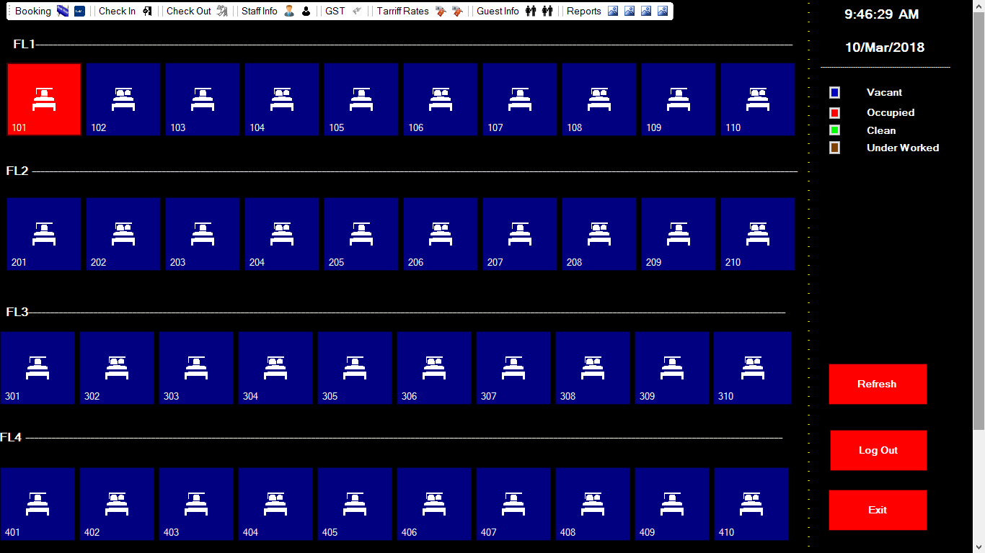

When Staff’s login to the interface:

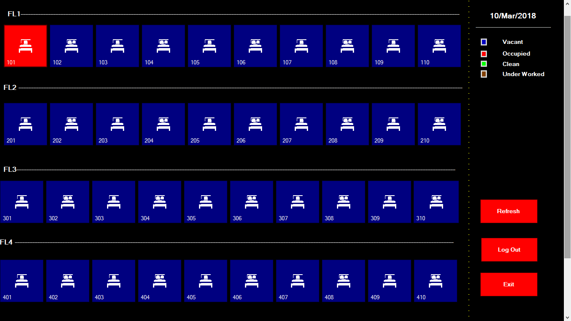

FrmBookingForm:-

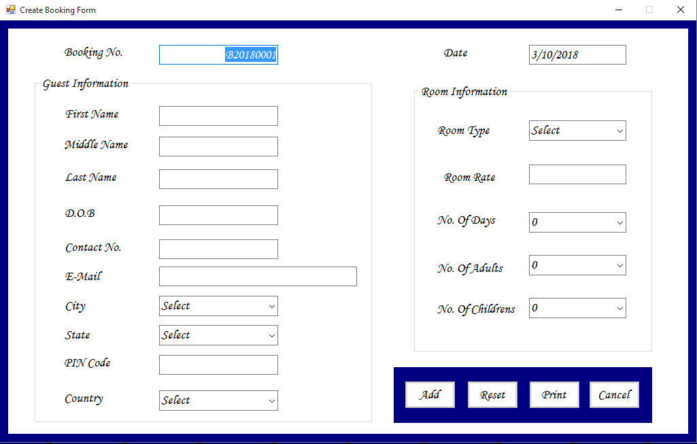

FrmGuestForm:-

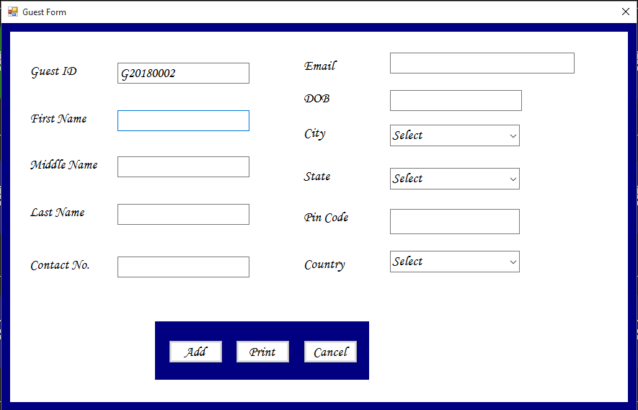

FrmStaffForm:-

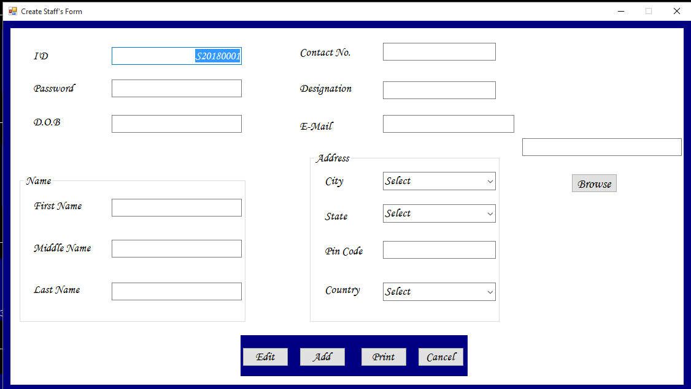

FrmCheckInForm:-

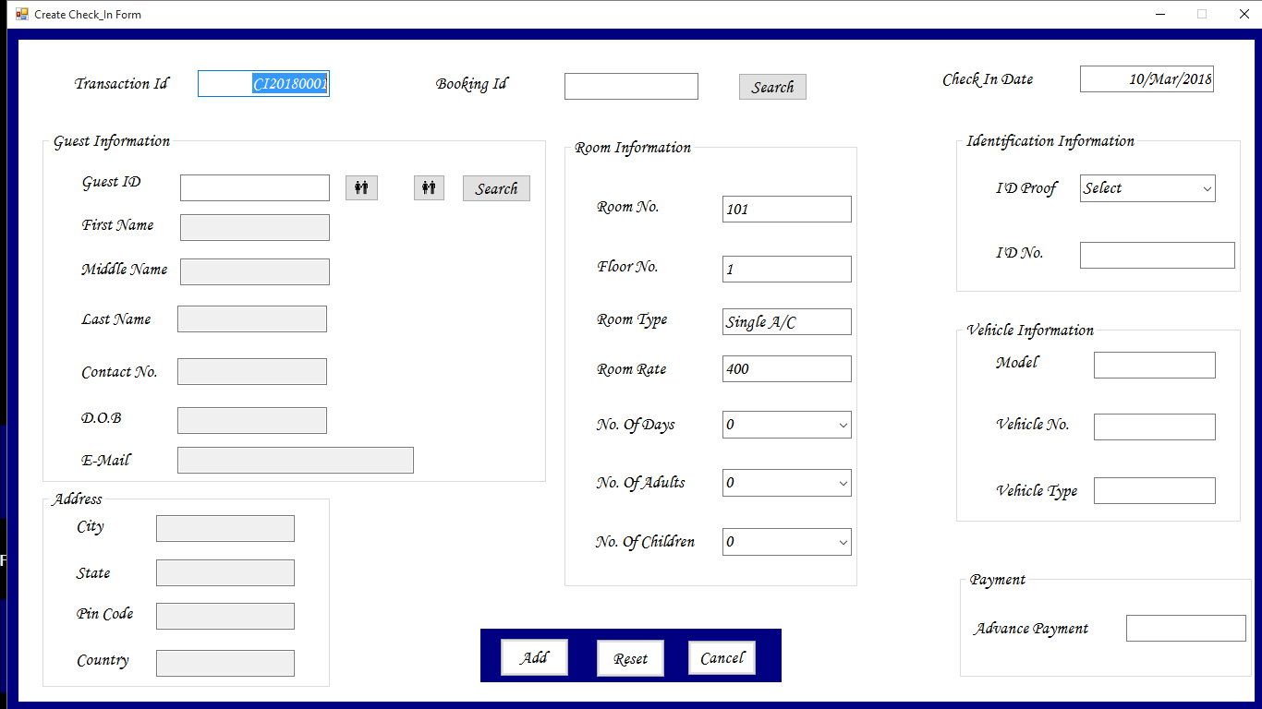

FrmCheckOutForm:-

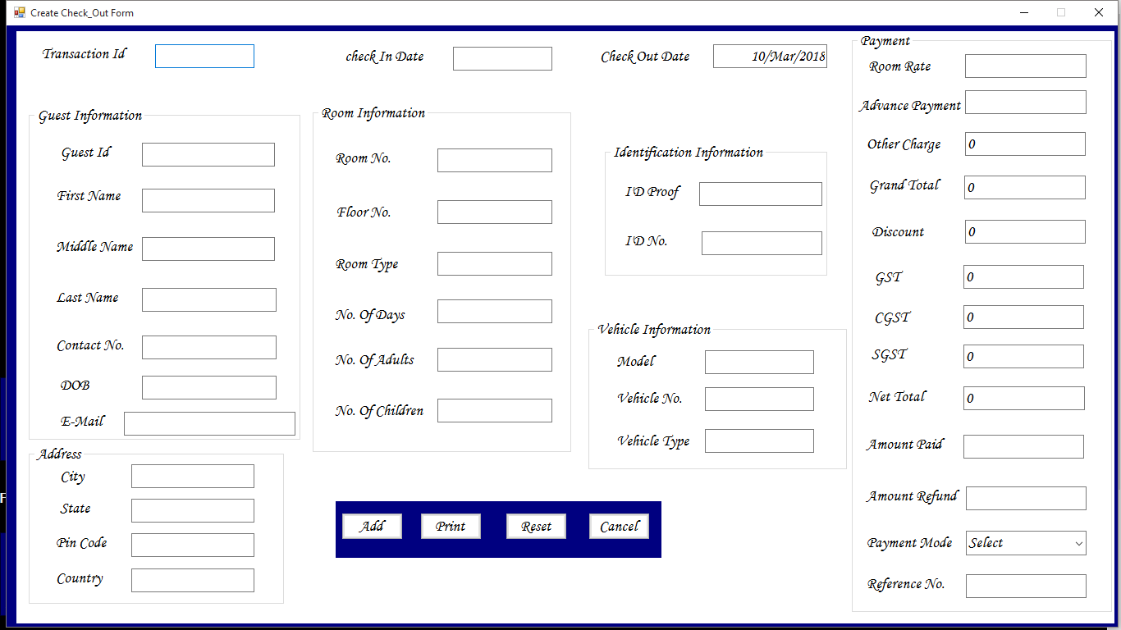

FrmLoginForm:-

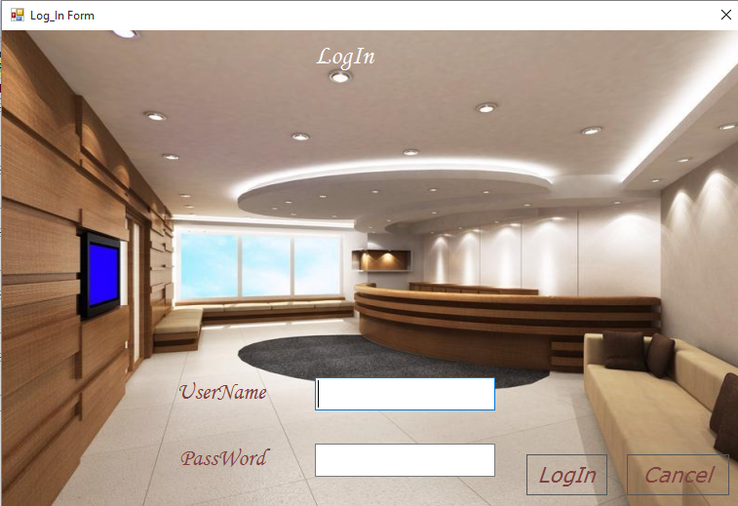

TblLoadingForm:-

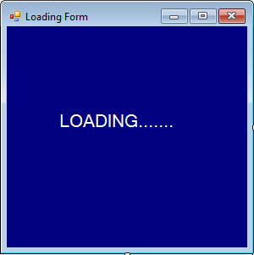

**Coding**

ModMain:-

Imports System.Data.SqlClient

ModulemdoMain

Public sqlcon AsNewSqlConnection("server=(localdb)\MSSQLLocalDB;Database=dbHotelManagementSystem;Integrated Security=True")

Public sqlcmd AsNewSqlCommand()

Public sqlDR AsSqlDataReader

Public sqlDA AsNewSqlDataAdapter()

Public DS AsNewDataSet()

Public DR AsDataRow

Public sqlCB AsNewSqlCommandBuilder(sqlDA)

EndModule

FrmBookingForm:-

PublicClassfrmBookingForm

PrivateSub btnAdd_Click(sender AsObject, e AsEventArgs) Handles btnAdd.Click

If txtFirstName.Text = ""Then

MessageBox.Show("Please enter first name!")

ElseIf txtLastName.Text = ""Then

MessageBox.Show("Please enter last name!")

Else

sqlcon.Open()

sqlcmd.Connection = sqlcon

sqlcmd.CommandText = "Select * from tblBooking"

sqlDA.SelectCommand = sqlcmd

sqlDA.Fill(DS, "tblBooking")

DR = DS.Tables("tblBooking").NewRow

DR("BookingNumber") = txtBookingNumber.Text

DR("Date") = txtDate.Text

DR("FirstName") = txtFirstName.Text

DR("MiddleName") = txtMiddleName.Text

DR("LastName") = txtLastName.Text

DR("DOB") = txtDOB.Text

DR("ContactNumber") = txtContactNumber.Text

DR("Email") = txtEmail.Text

DR("PINCode") = txtPinCode.Text

DR("City") = cmbCity.Text

DR("State") = cmbState.Text

DR("Country") = cmbCountry.Text

DR("NumberOfAdults") = cmbNumberOfAdults.Text

DR("NumberOfDays") = cmbNumberOfDays.Text

DR("NumberOfChildrens") = cmbNumberOfChildrens.Text

DR("RoomType") = cmbRoomType.Text

DR("RoomRate") = txtRoomRate.Text

DS.Tables("tblBooking").Rows.Add(DR)

sqlDA.Update(DS, "tblBooking")

MessageBox.Show("Booking Successfull.....")

sqlcon.Close()

FormReset()

EndIf

EndSub

PrivateSub btnCancel_Click(sender AsObject, e AsEventArgs) Handles btnCancel.Click

Me.Close()

EndSub

PrivateSub frmBookingForm_Load(sender AsObject, e AsEventArgs) HandlesMyBase.Load

Timer1.Start()

GenerateBookingNo()

sqlcon.Open()

sqlcmd.Connection = sqlcon

sqlcmd.CommandText = "Select StatesName from tblState"

sqlDR = sqlcmd.ExecuteReader()

While (sqlDR.Read())

cmbState.Items.Add(sqlDR("StatesName"))

EndWhile

sqlcon.Close()

sqlcon.Open()

sqlcmd.Connection = sqlcon

sqlcmd.CommandText = "select RoomType from tblTariff"

sqlDR = sqlcmd.ExecuteReader()

While (sqlDR.Read())

cmbRoomType.Items.Add(sqlDR("RoomType"))

EndWhile

sqlcon.Close()

EndSub

PrivateSub GenerateBookingNo()

sqlcon.Open()

sqlcmd.Connection = sqlcon

sqlcmd.CommandText = "select BookingNumber From tblBooking"

sqlDR = sqlcmd.ExecuteReader()

While (sqlDR.Read())

txtBookingNumber.Text = sqlDR(0)

EndWhile

If txtBookingNumber.Text <> vbNullString Then

Dim serial AsInteger = txtBookingNumber.Text.Substring(5, 4)

serial = serial + 1

txtBookingNumber.Text = "B"& Today.Year &"000"& serial

Else

txtBookingNumber.Text = "B"& Today.Year &"0001"

EndIf

sqlDR.Close()

sqlcon.Close()

EndSub

PrivateSub FormReset()

GenerateBookingNo()

txtFirstName.Clear()

txtMiddleName.Clear()

txtLastName.Clear()

txtContactNumber.Clear()

txtEmail.Clear()

txtDate.Clear()

txtDOB.Clear()

cmbCity.Text = "Select"

cmbState.Text = "Select"

txtPinCode.Clear()

cmbCountry.Text = "Select"

txtRoomRate.Clear()

cmbRoomType.Text = "Select"

cmbNumberOfDays.Text = "Select"

cmbNumberOfAdults.Text = "Select"

cmbNumberOfChildrens.Text = "Select"

EndSub

PrivateSub btnRset_Click(sender AsObject, e AsEventArgs) Handles btnRset.Click

GenerateBookingNo()

txtFirstName.Clear()

txtMiddleName.Clear()

txtLastName.Clear()

txtContactNumber.Clear()

txtEmail.Clear()

txtDate.Clear()

cmbCity.Text = "Select"

cmbState.Text = "Select"

txtPinCode.Clear()

cmbCountry.Text = "Select"

txtRoomRate.Clear()

cmbRoomType.Text = "Select"

cmbNumberOfDays.Text = "Select"

cmbNumberOfAdults.Text = "Select"

cmbNumberOfChildrens.Text = "Select"

EndSub

PrivateSub txtDate_TextChanged(sender AsObject, e AsEventArgs) Handles txtDate.TextChanged

txtDate.Text = Today.Date

EndSub

PrivateSub Timer1_Tick(sender AsObject, e AsEventArgs) Handles Timer1.Tick

txtDate.Text = Date.Now.ToString("dd/MMM/yyyy")

EndSub

PrivateSub cmbRoomType_Leave(sender AsObject, e AsEventArgs) Handles cmbRoomType.Leave

EndSub

PrivateSub PrintDocument1_PrintPage(sender AsObject, e As Drawing.Printing.PrintPageEventArgs) Handles PrintDocument1.PrintPage

e.Graphics.DrawString("PQR Hotel", NewFont("Arial", 12, FontStyle.Bold), Brushes.Black, 300, 20)

e.Graphics.DrawString("Add :- Jai Prakash Nagar, Bairia, Muz. ", NewFont("Arial", 8, FontStyle.Regular), Brushes.Black, 260, 40)

e.Graphics.DrawString("Email :- Ashishk2323@outlook.com ", NewFont("Arial", 8, FontStyle.Regular), Brushes.Black, 260, 60)

e.Graphics.DrawString("Phone No. :- +91 7079736900 ", NewFont("Arial", 8, FontStyle.Regular), Brushes.Black, 260, 80)

e.Graphics.DrawLine(Pens.Black, 30, 100, 800, 100)

e.Graphics.DrawString("Booking Id :- ", NewFont("Arial", 12, FontStyle.Bold), Brushes.Black, 200, 120)

e.Graphics.DrawString("Date :- ", NewFont("Arial", 12, FontStyle.Bold), Brushes.Black, 600, 120)

e.Graphics.DrawString("Name :- ", NewFont("Arial", 12, FontStyle.Underline), Brushes.Black, 50, 160)

e.Graphics.DrawString("First Name - ", NewFont("Arial", 8, FontStyle.Regular), Brushes.Black, 70, 190)

e.Graphics.DrawString("Middle Name - ", NewFont("Arial", 8, FontStyle.Regular), Brushes.Black, 70, 220)

e.Graphics.DrawString("Last Name - ", NewFont("Arial", 8, FontStyle.Regular), Brushes.Black, 70, 250)

e.Graphics.DrawString("Address :- ", NewFont("Arial", 12, FontStyle.Underline), Brushes.Black, 50, 280)

e.Graphics.DrawString("City - ", NewFont("Arial", 8, FontStyle.Regular), Brushes.Black, 70, 310)

e.Graphics.DrawString("Pin Code - ", NewFont("Arial", 8, FontStyle.Regular), Brushes.Black, 70, 340)

e.Graphics.DrawString("State - ", NewFont("Arial", 8, FontStyle.Regular), Brushes.Black, 70, 370)

e.Graphics.DrawString("Country - ", NewFont("Arial", 8, FontStyle.Regular), Brushes.Black, 70, 400)

e.Graphics.DrawString("About Room :- ", NewFont("Arial", 12, FontStyle.Underline), Brushes.Black, 50, 430)

e.Graphics.DrawString("Room Type - ", NewFont("Arial", 8, FontStyle.Regular), Brushes.Black, 70, 460)

e.Graphics.DrawString("Room Rate - ", NewFont("Arial", 8, FontStyle.Regular), Brushes.Black, 70, 490)

e.Graphics.DrawString("Payment :- ", NewFont("Arial", 12, FontStyle.Underline), Brushes.Black, 50, 520)

e.Graphics.DrawString("Advance Payment - ", NewFont("Arial", 8, FontStyle.Regular), Brushes.Black, 70, 550)

e.Graphics.DrawString("Payment Mode - ", NewFont("Arial", 8, FontStyle.Regular), Brushes.Black, 70, 580)

EndSub

PrivateSub btnPrint_Click(sender AsObject, e AsEventArgs) Handles btnPrint.Click

PrintDialog1.PrinterSettings = PrintDocument1.PrinterSettings

If PrintDialog1.ShowDialog() = DialogResult.OK Then

PrintDocument1.PrinterSettings = PrintDocument1.PrinterSettings

PrintDocument1.Print()

EndIf

EndSub

PrivateSub cmbRoomType_SelectedIndexChanged(sender AsObject, e AsEventArgs) Handles cmbRoomType.SelectedIndexChanged

sqlcon.Open()

sqlcmd.Connection = sqlcon

sqlcmd.CommandText = "Select * from tblTariff where RoomType='"& cmbRoomType.Text &"'"

sqlDR = sqlcmd.ExecuteReader()

While sqlDR.Read

txtRoomRate.Text = sqlDR("NewRate")

EndWhile

sqlDR.Close()

sqlcon.Close()

EndSub

EndClass

FrmEditBookingForm:-

Imports System.ComponentModel

PublicClassfrmEditBookingForm

PrivateSub btnCancel_Click(sender AsObject, e AsEventArgs) Handles btnCancel.Click

Me.Close()

EndSub

PrivateSub btnUpdate_Click(sender AsObject, e AsEventArgs) Handles btnUpdate.Click

sqlcon.Open()

sqlcmd.Connection = sqlcon

sqlcmd.CommandText = "Select * from tblBooking Where BookingNumber='"& txtBookingNumber.Text &"'"

sqlDA.SelectCommand = sqlcmd

sqlDA.Fill(DS, "tblBooking")

DR = DS.Tables("tblBooking").NewRow

DR("BookingNumber") = txtBookingNumber.Text

DR("Date") = txtDate.Text

DR("FirstName") = txtFirstName.Text

DR("MiddleName") = txtMiddleName.Text

DR("LastName") = txtLastName.Text

DR("DOB") = dtpDOB.Text

DR("ContactNumber") = txtContactNUmber.Text

DR("Email") = txtEmail.Text

DR("PINCode") = txtPinCode.Text

DR("City") = cmbCity.Text

DR("State") = cmbState.Text

DR("Country") = cmbCountry.Text

DR("NumberOfAdults") = cmbNumberOfAdults.Text

DR("NumberOfDays") = cmbNumberOfDays.Text

DR("NumberOfChildrens") = cmbNUmberOfChildrens.Text

DR("RoomType") = cmbRoomType.Text

DR("RoomRate") = cmbRoomRate.Text

sqlDA.Update(DS, "tblBooking")

MessageBox.Show("Booking Successfull.....")

sqlcon.Close()

FormReset()

EndSub

PrivateSub FormReset()

txtFirstName.Clear()

txtMiddleName.Clear()

txtLastName.Clear()

txtContactNUmber.Clear()

txtEmail.Clear()

txtDate.Clear()

txtBookingNumber.Clear()

cmbCity.Text = "Select"

cmbState.Text = "Select"

txtPinCode.Clear()

cmbCountry.Text = "Select"

cmbRoomRate.Text = "Select"

cmbRoomType.Text = "Select"

cmbNumberOfDays.Text = "Select"

cmbNumberOfAdults.Text = "Select"

cmbNUmberOfChildrens.Text = "Select"

EndSub

PrivateSub btnSearch_Click(sender AsObject, e AsEventArgs) Handles btnSearch.Click

sqlcon.Open()

sqlcmd.Connection = sqlcon

sqlcmd.CommandText = "Select * from tblBooking where BookingNumber='"& txtBookingNumber.Text &"'"

sqlDR = sqlcmd.ExecuteReader()

If (sqlDR.Read()) Then

txtFirstName.Text = sqlDR("FirstName")

txtMiddleName.Text = sqlDR("MiddleName")

txtLastName.Text = sqlDR("LastName")

txtEmail.Text = sqlDR("Email")

txtDate.Text = sqlDR("Date")

txtContactNUmber.Text = sqlDR("ContactNumber")

cmbCity.Text = sqlDR("City")

cmbCountry.Text = sqlDR("Country")

cmbNumberOfAdults.Text = sqlDR("NumberOfAdults")

cmbNUmberOfChildrens.Text = sqlDR("NUmberOfChildrens")

cmbNumberOfDays.Text = sqlDR("NumberOfDays")

txtPinCode.Text = sqlDR("PinCode")

cmbRoomRate.Text = sqlDR("RoomRate")

cmbRoomType.Text = sqlDR("RoomType")

cmbState.Text = sqlDR("State")

txtBookingNumber.ReadOnly = True

btnEdit.Enabled = True

Else

MessageBox.Show("No bookings found, please retry...")

EndIf

sqlcon.Close()

EndSub

PrivateSub btnEdit_Click(sender AsObject, e AsEventArgs) Handles btnEdit.Click

sqlcon.Open()

sqlcmd.Connection = sqlcon

sqlcmd.CommandText = "Select * from tblBooking where BookingNumber='"& txtBookingNumber.Text &"'"

sqlDR = sqlcmd.ExecuteReader()

If (sqlDR.Read()) Then

btnEdit.Enabled = True

btnUpdate.Enabled = True

Else

btnUpdate.Enabled = False

EndIf

sqlcon.Close()

EndSub

PrivateSub frmEditBookingForm_Load(sender AsObject, e AsEventArgs) HandlesMyBase.Load

Timer1.Start()

sqlcon.Open()

sqlcmd.Connection = sqlcon

sqlcmd.CommandText = "Select StatesName from tblState"

sqlDR = sqlcmd.ExecuteReader()

While (sqlDR.Read())

cmbState.Items.Add(sqlDR("StatesName"))

EndWhile

sqlcon.Close()

EndSub

PrivateSub Timer1_Tick(sender AsObject, e AsEventArgs) Handles Timer1.Tick

txtDate.Text = Date.Now.ToString("dd/MMM/yyyy")

EndSub

EndClass

FrmCheckInForm:-

PublicClassfrmCheckInForm

PrivateSub btnCancel_Click(sender AsObject, e AsEventArgs) Handles btnCancel.Click

Me.Close()

EndSub

PrivateSub btnAdd_Click(sender AsObject, e AsEventArgs) Handles btnAdd.Click

sqlcon.Open()

sqlcmd.Connection = sqlcon

sqlcmd.CommandText = "Select * from tblTransaction"

sqlDA.SelectCommand = sqlcmd

sqlDA.Fill(DS, "tblTransaction")

DR = DS.Tables("tblTransaction").NewRow

DR("TransactionId") = txtTransactionId.Text

DR("CheckInDate") = txtCheckInDate.Text

DR("GuestID") = txtGuestId.Text

DR("BookingId") = txtBookingId.Text

DR("NumberOfAdults") = cmbNumberOfAdults.Text

DR("NumberOfDays") = cmbNoOfDays.Text

DR("NumberOfChildrens") = cmbNoOfChildrens.Text

DR("RoomType") = txtRoomType.Text

DR("RoomNumber") = txtRoomNumber.Text

DR("FloorNumber") = txtFloorNumber.Text

DR("IdProof") = cmbIdProof.Text

DR("VehicleNo") = txtVehicleNo.Text

DR("Model") = txtMOdel.Text

DR("IdNumber") = txtIdNumber.Text

DR("VehicleType") = txtVehicleType.Text

DR("AdvancePayment") = txtAdvancePayment.Text

DR("RoomRate") = txtRoomRate.Text

DS.Tables("tblTransaction").Rows.Add(DR)

sqlDA.Update(DS, "tblTransaction")

sqlcmd.CommandText = "Update tblRoom set Status='O' where RoomNumber='"& txtRoomNumber.Text &"'"

sqlcmd.ExecuteNonQuery()

MessageBox.Show("CheckIn Successfull.....")

sqlcon.Close()

frmMainForm.FormLoad()

FormReset()

EndSub

PrivateSub frmCheckInForm_Load(sender AsObject, e AsEventArgs) HandlesMyBase.Load

Timer1.Start()

GenerateTransactionId()

EndSub

PrivateSub GenerateTransactionId()

sqlcon.Open()

sqlcmd.Connection = sqlcon

sqlcmd.CommandText = "select TransactionId From tblTransaction"

sqlDR = sqlcmd.ExecuteReader()

While (sqlDR.Read())

txtTransactionId.Text = sqlDR(0)

EndWhile

If txtTransactionId.Text <> vbNullString Then

Dim serial AsInteger = txtTransactionId.Text.Substring(6, 4)

serial = serial + 1

txtTransactionId.Text = "CI"& Today.Year &"000"& serial

Else

txtTransactionId.Text = "CI"& Today.Year &"0001"

EndIf

sqlDR.Close()

sqlcon.Close()

EndSub

PrivateSub FormReset()

GenerateTransactionId()

txtGuestId.Clear()

txtFirstName.Clear()

txtMIddleName.Clear()

txtLastName.Clear()

txtContactNo.Clear()

txtEmail.Clear()

txtDOB.Clear()

txtIdNumber.Clear()

txtCity.Clear()

txtState.Clear()

txtCountry.Clear()

txtPinCode.Clear()

txtRoomNumber.Clear()

txtFloorNumber.Clear()

txtRoomType.Clear()

cmbNoOfDays.Text = "Select"

cmbNumberOfAdults.Text = "Select"

cmbNoOfChildrens.Text = "Select"

cmbIdProof.Text = "Select"

txtMOdel.Text = "Select"

txtVehicleNo.Text = "Select"

txtVehicleType.Text = "Select"

txtAdvancePayment.Clear()

txtBookingId.Clear()

txtRoomRate.Clear()

EndSub

PrivateSub btnReset_Click(sender AsObject, e AsEventArgs) Handles btnReset.Click

GenerateTransactionId()

txtGuestId.Clear()

txtFirstName.Clear()

txtMIddleName.Clear()

txtLastName.Clear()

txtContactNo.Clear()

txtEmail.Clear()

txtCheckInDate.Clear()

txtCity.Clear()

txtState.Clear()

txtPinCode.Clear()

txtCountry.Clear()

txtRoomNumber.Clear()

txtFloorNumber.Clear()

txtRoomType.Clear()

cmbNoOfDays.Text = "Select"

cmbNumberOfAdults.Text = "Select"

cmbNoOfChildrens.Text = "Select"

cmbIdProof.Text = "Select"

txtMOdel.Clear()

txtVehicleNo.Clear()

txtIdNumber.Clear()

txtVehicleType.Clear()

txtRoomRate.Clear()

EndSub

PrivateSub Timer1_Tick(sender AsObject, e AsEventArgs) Handles Timer1.Tick

txtCheckInDate.Text = Date.Now.ToString("dd/MMM/yyyy")

EndSub

PrivateSub btnGuestForm_Click(sender AsObject, e AsEventArgs) Handles btnGuestForm.Click

frmGuestForm.Show()

EndSub

PrivateSub btnEditGuestForm_Click(sender AsObject, e AsEventArgs) Handles btnEditGuestForm.Click

frmEditGuestForm.Show()

EndSub

PrivateSub btnBookingSearch_Click(sender AsObject, e AsEventArgs) Handles btnBookingSearch.Click

sqlcon.Open()

sqlcmd.Connection = sqlcon

sqlcmd.CommandText = "Select * from tblBooking where BookingId='"& txtBookingId.Text &"'"

sqlDR = sqlcmd.ExecuteReader()

If (sqlDR.Read()) Then

txtFirstName.Text = sqlDR("FirstName")

txtMIddleName.Text = sqlDR("MiddleName")

txtLastName.Text = sqlDR("LastName")

txtEmail.Text = sqlDR("Email")

txtCheckInDate.Text = sqlDR("Date")

txtContactNo.Text = sqlDR("ContactNumber")

txtCity.Text = sqlDR("City")

txtCountry.Text = sqlDR("Country")

cmbNumberOfAdults.Text = sqlDR("NumberOfAdults")

cmbNoOfChildrens.Text = sqlDR("NUmberOfChildrens")

cmbNoOfDays.Text = sqlDR("NumberOfDays")

txtPinCode.Text = sqlDR("PinCode")

txtRoomRate.Text = sqlDR("RoomRate")

txtRoomType.Text = sqlDR("RoomType")

txtState.Text = sqlDR("State")

txtBookingId.ReadOnly = True

Else

MessageBox.Show("No bookings found, please retry...")

EndIf

sqlcon.Close()

EndSub

PrivateSub btnGuestSearch_Click(sender AsObject, e AsEventArgs) Handles btnGuestSearch.Click

sqlcon.Open()

sqlcmd.Connection = sqlcon

sqlcmd.CommandText = "Select * from tblGuest where GuestID='"& txtGuestId.Text &"'"

sqlDR = sqlcmd.ExecuteReader()

If (sqlDR.Read()) Then

txtFirstName.Text = sqlDR("FirstName")

txtMIddleName.Text = sqlDR("MiddleName")

txtLastName.Text = sqlDR("LastName")

txtEmail.Text = sqlDR("Email")

txtContactNo.Text = sqlDR("ContactNumber")

txtCity.Text = sqlDR("City")

txtCountry.Text = sqlDR("Country")

txtDOB.Text = sqlDR("DOB")

txtPinCode.Text = sqlDR("PinCode")

txtState.Text = sqlDR("State")

txtGuestId.ReadOnly = True

Else

MessageBox.Show("No Guest found, please retry...")

EndIf

sqlcon.Close()

EndSub

EndClass

FrmEditCheckInForm:-

PublicClassfrmEditCheck_InForm

PrivateSub btnCancel_Click(sender AsObject, e AsEventArgs) Handles btnCancel.Click

Me.Close()

EndSub

PrivateSub btnUpdate_Click(sender AsObject, e AsEventArgs) Handles btnUpdate.Click

sqlcon.Open()

sqlcmd.Connection = sqlcon

sqlcmd.CommandText = "Select * from tblCheckIn"

sqlDA.SelectCommand = sqlcmd

sqlDA.Fill(DS, "tblCheckIn")

DR = DS.Tables("tblCheckIn").NewRow

DR("CheckInNumber") = txtCheckInNumber.Text

DR("Date") = txtDate.Text

DR("FirstName") = txtFirstName.Text

DR("MiddleName") = txtMiddleName.Text

DR("LastName") = txtLastName.Text

DR("ContactNumber") = txtContactNumber.Text

DR("Email") = txtEmail.Text

DR("PINCode") = txtPinCode.Text

DR("City") = cmbCity.Text

DR("State") = cmbState.Text

DR("Country") = cmbCountry.Text

DR("NumberOfAdults") = cmbNumberOfAdults.Text

DR("NumberOfDays") = cmbNumberOfDays.Text

DR("NumberOfChildrens") = cmbNumberOfChildrens.Text

DR("RoomType") = cmbRoomType.Text

DR("RoomNumber") = cmbRoomNumber.Text

DR("FloorNumber") = cmbFloorNumber.Text

DR("IdProof") = cmbIdProof.Text

DR("VehicleNumber") = txtVehicleNumber.Text

DR("Model") = txtModel.Text

DR("IdNumber") = txtIdNumber.Text

DR("VehicleType") = txtVehicleType.Text

DR("AmountPayable") = txtAmountPayable.Text

sqlDA.Update(DS, "tblCheckIn")

MessageBox.Show("CheckIn Successfull.....")

sqlcon.Close()

FormReset()

EndSub

PrivateSub FormReset()

txtFirstName.Clear()

txtMiddleName.Clear()

txtLastName.Clear()

txtContactNumber.Clear()

txtEmail.Clear()

txtDate.Clear()

cmbCity.Text = "Select"

cmbState.Text = "Select"

txtPinCode.Clear()

cmbCountry.Text = "Select"

cmbRoomNumber.Text = "Select"

cmbFloorNumber.Text = "Select"

cmbRoomType.Text = "Select"

cmbNumberOfDays.Text = "Select"

cmbNumberOfAdults.Text = "Select"

cmbNumberOfChildrens.Text = "Select"

cmbIdProof.Text = "Select"

txtModel.Clear()

txtIdNumber.Clear()

txtVehicleNumber.Clear()

txtVehicleType.Clear()

txtAmountPayable.Clear()

EndSub

PrivateSub frmEditCheck_InForm_Load(sender AsObject, e AsEventArgs) HandlesMyBase.Load

Timer1.Start()

sqlcon.Open()

sqlcmd.Connection = sqlcon

sqlcmd.CommandText = "Select StatesName from tblState"

sqlDR = sqlcmd.ExecuteReader()

While (sqlDR.Read())

cmbState.Items.Add(sqlDR("StatesName"))

EndWhile

sqlcon.Close()

EndSub

PrivateSub btnSearch_Click(sender AsObject, e AsEventArgs) Handles btnSearch.Click

sqlcon.Open()

sqlcmd.Connection = sqlcon

sqlcmd.CommandText = "Select * from tblCheckIn where CheckInNumber='"& txtCheckInNumber.Text &"'"

sqlDR = sqlcmd.ExecuteReader()

If (sqlDR.Read()) Then

txtFirstName.Text = sqlDR("FirstName")

txtMiddleName.Text = sqlDR("MiddleName")

txtLastName.Text = sqlDR("LastName")

txtEmail.Text = sqlDR("Email")

txtDate.Text = sqlDR("Date")

txtContactNumber.Text = sqlDR("ContactNumber")

cmbCity.Text = sqlDR("City")

cmbCountry.Text = sqlDR("Country")

cmbNumberOfAdults.Text = sqlDR("NumberOfAdults")

cmbNumberOfChildrens.Text = sqlDR("NUmberOfChildrens")

cmbNumberOfDays.Text = sqlDR("NumberOfDays")

txtPinCode.Text = sqlDR("PinCode")

cmbRoomNumber.Text = sqlDR("RoomNumber")

cmbRoomType.Text = sqlDR("RoomType")

cmbState.Text = sqlDR("State")

cmbCity.Text = sqlDR("City")

cmbFloorNumber.Text = sqlDR("FloorNumber")

cmbIdProof.Text = sqlDR("IdProof")

txtModel.Text = sqlDR("Model")

txtVehicleNumber.Text = sqlDR("VehicleNumber")

txtVehicleType.Text = sqlDR("VehicleType")

txtCheckInNumber.ReadOnly = True

btnEdit.Enabled = True

Else

MessageBox.Show("No bookings found, please retry...")

EndIf

sqlcon.Close()

EndSub

PrivateSub btnEdit_Click(sender AsObject, e AsEventArgs) Handles btnEdit.Click

sqlcon.Open()

sqlcmd.Connection = sqlcon

sqlcmd.CommandText = "Select * from tblCheckIn where CheckInNumber='"& txtCheckInNumber.Text &"'"

sqlDR = sqlcmd.ExecuteReader()

If (sqlDR.Read()) Then

btnEdit.Enabled = True

btnUpdate.Enabled = True

EndIf

sqlcon.Close()

EndSub

PrivateSub Timer1_Tick(sender AsObject, e AsEventArgs) Handles Timer1.Tick

txtDate.Text = Date.Now.ToString("dd/MMM/yyyy")

EndSub

EndClass

FrmCheckOutForm:-

PublicClassfrmCheckOutForm

PrivateSub btnCancel_Click(sender AsObject, e AsEventArgs) Handles btnCancel.Click

Me.Close()

EndSub

PrivateSub btnAdd_Click(sender AsObject, e AsEventArgs) Handles btnAdd.Click

sqlcon.Open()

sqlcmd.Connection = sqlcon

sqlcmd.CommandText = "Select * from tblTransaction Where TransactionId='"& txtTransactionId.Text &"'"

sqlDA.SelectCommand = sqlcmd

sqlDA.Fill(DS, "tblTransaction")

DR = DS.Tables("tblTransaction").NewRow

DR("TransactionId") = txtTransactionId.Text

DR("CheckInDate") = txtCheckInDate.Text

DR("CheckOutDate") = txtCheckOutDate.Text

DR("GuestId") = txtGuestId.Text

DR("IdNumber") = txtIdNumber.Text

DR("NumberOfAdults") = txtNumberOfAdults.Text

DR("NumberOfDays") = txtNumberOfDays.Text

DR("NumberOfChildrens") = txtNumberOfChildrens.Text

DR("RoomType") = txtRoomType.Text

DR("RoomNumber") = txtRoomNumber.Text

DR("FloorNumber") = txtFloorNumber.Text

DR("IdProof") = txtIdProof.Text

DR("VehicleNo") = txtVehicleNo.Text

DR("Model") = txtModel.Text

DR("VehicleType") = txtVehicleType.Text

DR("AmountRefund") = txtAmountRefund.Text

DR("ReferenceNumber") = txtReferenceNumber.Text

DR("GrandTotal") = txtDiscount.Text

DR("NetTotal") = txtNetTotal.Text

DR("CGST") = txtCGST.Text

DR("SGST") = txtSGST.Text

DR("GST") = txtGST.Text

DR("AdvancePayment") = txtAdvancePayment.Text

DR("Discount") = txtGrandTotal.Text

DR("RoomRate") = txtRoomRate.Text

'DS.Tables("tblTransaction").Rows.Add(DR)

sqlDA.Update(DS, "tblTransaction")

'--------- Setting Room Status ---------------

sqlcmd.CommandText = "Update tblRoom set Status='V' where RoomNumber = '"& txtRoomNumber.Text &"'"

sqlcmd.ExecuteNonQuery()

MessageBox.Show("Checkout Successfull.....")

sqlcon.Close()

FormReset()

EndSub

PrivateSub FormReset()

txtGuestId.Clear()

txtFirstName.Clear()

txtMiddleName.Clear()

txtLastName.Clear()

txtContactNo.Clear()

txtDOB.Clear()

txtEmail.Clear()

txtIdNumber.Clear()

txtCity.Clear()

txtState.Clear()

txtPinCode.Clear()

txtCountry.Clear()

txtRoomNumber.Clear()

txtFloorNumber.Clear()

txtRoomType.Clear()

txtNumberOfDays.Clear()

txtNumberOfAdults.Clear()

txtNumberOfChildrens.Clear()

txtAdvancePayment.Clear()

txtIdProof.Clear()

txtModel.Text = "Select"

txtVehicleNo.Text = "Select"

txtVehicleType.Text = "Select"

txtAmountRefund.Text = "Select"

txtAmountPaid.Clear()

txtOtherCharge.Clear()

txtRoomRate.Clear()

txtGST.Clear()

txtDiscount.Text = "Select"

txtGrandTotal.Text = "Select"

cmbPaymentMode.Text = "Select"

EndSub

PrivateSub btnReset_Click(sender AsObject, e AsEventArgs) Handles btnReset.Click

txtTransactionId.Clear()

txtCheckInDate.Clear()

txtGST.Clear()

txtFirstName.Clear()

txtMiddleName.Clear()

txtLastName.Clear()

txtDOB.Clear()

txtAmountPaid.Clear()

txtOtherCharge.Clear()

txtRoomRate.Clear()

txtIdNumber.Clear()

txtNumberOfAdults.Clear()

txtNumberOfChildrens.Clear()

txtNumberOfDays.Clear()

cmbPaymentMode.Text = "Select"

txtRoomNumber.Clear()

txtAdvancePayment.Clear()

txtDiscount.Text = "Select"

txtGrandTotal.Text = "Select"

EndSub

PrivateSub frmCheckOutForm_Load(sender AsObject, e AsEventArgs) HandlesMyBase.Load

txtCheckOutDate.Text = Date.Now.ToString("dd/MMM/yyyy")

EndSub

PrivateSub txtDiscount_Leave(sender AsObject, e AsEventArgs) Handles txtDiscount.Leave

Dim d AsInteger = 0

d = (txtDiscount.Text / 100) * txtGrandTotal.Text

txtNetTotal.Text = txtGrandTotal.Text - d + (txtGST.Text / 100)

EndSub

PrivateSub txtOtherCharge_Leave(sender AsObject, e AsEventArgs) Handles txtOtherCharge.Leave

txtGrandTotal.Text = txtRoomRate.Text - txtAdvancePayment.Text + txtOtherCharge.Text

EndSub

PrivateSub txtAmountPaid_Leave(sender AsObject, e AsEventArgs) Handles txtAmountPaid.Leave

txtAmountRefund.Text = txtAmountPaid.Text - txtNetTotal.Text

EndSub

PrivateSub cmbPaymentMode_SelectedIndexChanged(sender AsObject, e AsEventArgs) Handles cmbPaymentMode.SelectedIndexChanged

EndSub

PrivateSub cmbPaymentMode_Leave(sender AsObject, e AsEventArgs) Handles cmbPaymentMode.Leave

If cmbPaymentMode.Text = "card"Then

txtReferenceNumber.Visible = True

ElseIf cmbPaymentMode.Text = "Cash"

lblReferenceNumber.Visible = False

txtReferenceNumber.Visible = False

EndIf

EndSub

PrivateSub PrintDocument1_PrintPage(sender AsObject, e As Drawing.Printing.PrintPageEventArgs) Handles PrintDocument1.PrintPage

e.Graphics.DrawString("PQR Hotel", NewFont("Arial", 12, FontStyle.Bold), Brushes.Black, 300, 20)

e.Graphics.DrawString("Add :- Jai Prakash Nagar, Bairia, Muz. ", NewFont("Arial", 8, FontStyle.Regular), Brushes.Black, 260, 40)

e.Graphics.DrawString("Email :- Ashishk2323@outlook.com ", NewFont("Arial", 8, FontStyle.Regular), Brushes.Black, 260, 60)

e.Graphics.DrawString("Phone No. :- +91 7079736900 ", NewFont("Arial", 8, FontStyle.Regular), Brushes.Black, 260, 80)

e.Graphics.DrawLine(Pens.Black, 30, 100, 800, 100)

e.Graphics.DrawString("Transaction Id :- ", NewFont("Arial", 9, FontStyle.Bold), Brushes.Black, 50, 120)

e.Graphics.DrawString(" CheckOut Date :- ", NewFont("Arial", 9, FontStyle.Bold), Brushes.Black, 600, 120)

e.Graphics.DrawString("Name :- ", NewFont("Arial", 12, FontStyle.Underline), Brushes.Black, 50, 160)

e.Graphics.DrawString("First Name - ", NewFont("Arial", 8, FontStyle.Regular), Brushes.Black, 70, 190)

e.Graphics.DrawString("Middle Name - ", NewFont("Arial", 8, FontStyle.Regular), Brushes.Black, 70, 220)

e.Graphics.DrawString("Last Name - ", NewFont("Arial", 8, FontStyle.Regular), Brushes.Black, 70, 250)

e.Graphics.DrawString("Address :- ", NewFont("Arial", 12, FontStyle.Underline), Brushes.Black, 50, 280)

e.Graphics.DrawString("City - ", NewFont("Arial", 8, FontStyle.Regular), Brushes.Black, 70, 310)

e.Graphics.DrawString("Pin Code - ", NewFont("Arial", 8, FontStyle.Regular), Brushes.Black, 70, 340)

e.Graphics.DrawString("State - ", NewFont("Arial", 8, FontStyle.Regular), Brushes.Black, 70, 370)

e.Graphics.DrawString("Country - ", NewFont("Arial", 8, FontStyle.Regular), Brushes.Black, 70, 400)

e.Graphics.DrawString("Room Information :- ", NewFont("Arial", 12, FontStyle.Underline), Brushes.Black, 50, 430)

e.Graphics.DrawString("Room Type - ", NewFont("Arial", 8, FontStyle.Regular), Brushes.Black, 70, 460)

e.Graphics.DrawString("Room No. - ", NewFont("Arial", 8, FontStyle.Regular), Brushes.Black, 70, 490)

e.Graphics.DrawString("Room Rate - ", NewFont("Arial", 8, FontStyle.Regular), Brushes.Black, 70, 520)

e.Graphics.DrawString("No. of Days - ", NewFont("Arial", 8, FontStyle.Regular), Brushes.Black, 70, 550)

e.Graphics.DrawString("No. Of Adults - ", NewFont("Arial", 8, FontStyle.Regular), Brushes.Black, 70, 580)

e.Graphics.DrawString("No. Of Childrens - ", NewFont("Arial", 8, FontStyle.Regular), Brushes.Black, 70, 610)

e.Graphics.DrawString("Room Type - ", NewFont("Arial", 8, FontStyle.Regular), Brushes.Black, 70, 640)

e.Graphics.DrawString("Identification :- ", NewFont("Arial", 12, FontStyle.Underline), Brushes.Black, 50, 670)

e.Graphics.DrawString("Advance Payment - ", NewFont("Arial", 8, FontStyle.Regular), Brushes.Black, 70, 700)

e.Graphics.DrawString("Payment Mode - ", NewFont("Arial", 8, FontStyle.Regular), Brushes.Black, 70, 730)

e.Graphics.DrawLine(Pens.Black, 400, 150, 400, 750)

e.Graphics.DrawString("Vehicle Information :- ", NewFont("Arial", 12, FontStyle.Underline), Brushes.Black, 430, 160)

e.Graphics.DrawString("Model - ", NewFont("Arial", 8, FontStyle.Regular), Brushes.Black, 450, 190)

e.Graphics.DrawString("Vehicle Type - ", NewFont("Arial", 8, FontStyle.Regular), Brushes.Black, 450, 220)

e.Graphics.DrawString("Vehicle No. - ", NewFont("Arial", 8, FontStyle.Regular), Brushes.Black, 450, 250)

e.Graphics.DrawString("Payment :- ", NewFont("Arial", 12, FontStyle.Underline), Brushes.Black, 430, 280)

e.Graphics.DrawString("Advance Payment - ", NewFont("Arial", 8, FontStyle.Regular), Brushes.Black, 450, 310)

e.Graphics.DrawString("Grand Total - ", NewFont("Arial", 8, FontStyle.Regular), Brushes.Black, 450, 340)

e.Graphics.DrawString("Other Charge - ", NewFont("Arial", 8, FontStyle.Regular), Brushes.Black, 450, 370)

e.Graphics.DrawString("Discount - ", NewFont("Arial", 8, FontStyle.Regular), Brushes.Black, 450, 400)

e.Graphics.DrawString("Net Total - ", NewFont("Arial", 8, FontStyle.Regular), Brushes.Black, 450, 430)

e.Graphics.DrawString("Amount Paid - ", NewFont("Arial", 8, FontStyle.Regular), Brushes.Black, 450, 460)

e.Graphics.DrawString("Amount Refund - ", NewFont("Arial", 8, FontStyle.Regular), Brushes.Black, 450, 490)

e.Graphics.DrawString("Payment Mode - ", NewFont("Arial", 8, FontStyle.Regular), Brushes.Black, 450, 520)

e.Graphics.DrawString("Reference No. - ", NewFont("Arial", 8, FontStyle.Regular), Brushes.Black, 450, 550)

e.Graphics.DrawLine(Pens.Blue, 430, 580, 800, 580)

e.Graphics.DrawString(".......Tax....... ", NewFont("Arial", 12, FontStyle.Italic), Brushes.Black, 550, 590)

e.Graphics.DrawLine(Pens.Blue, 430, 630, 800, 630)

e.Graphics.DrawString("GST - ", NewFont("Arial", 8, FontStyle.Regular), Brushes.Black, 450, 660)

e.Graphics.DrawString("CGST - ", NewFont("Arial", 8, FontStyle.Regular), Brushes.Black, 450, 690)

e.Graphics.DrawString("SGST - ", NewFont("Arial", 8, FontStyle.Regular), Brushes.Black, 450, 720)

EndSub

PrivateSub btnPrint_Click(sender AsObject, e AsEventArgs) Handles btnPrint.Click

PrintDialog1.PrinterSettings = PrintDocument1.PrinterSettings

If PrintDialog1.ShowDialog() = DialogResult.OK Then

PrintDocument1.PrinterSettings = PrintDocument1.PrinterSettings

PrintDocument1.Print()

EndIf

EndSub

PrivateSub txtDiscount_TextChanged(sender AsObject, e AsEventArgs) Handles txtDiscount.TextChanged

EndSub

EndClass

FrmEditCheckOutForm:-

PublicClassfrmEditCheck_OutForm

PrivateSub btnAdd_Click(sender AsObject, e AsEventArgs) Handles btnAdd.Click

sqlcon.Open()

sqlcmd.Connection = sqlcon

sqlcmd.CommandText = "Select * from tblCheckOut"

sqlDA.SelectCommand = sqlcmd

sqlDA.Fill(DS, "tblCheckOut")

DR = DS.Tables("tblCheckOut").NewRow

DR("DateIn") = txtDateIn.Text

DR("DateOut") = txtDateOut.Text

DR("GuestName") = txtGuestName.Text

DR("RoomCharge") = txtRoomCharge.Text

DR("OtherCharge") = txtOtherCharge.Text

DR("Discount") = txtDiscount.Text

DR("Total") = txtTotal.Text

DR("AmountPaid") = txtAmountPaid.Text

DR("PaymentMode") = cmbPaymentMode.Text

DR("NumberOfAdults") = cmbNumberOfAdults.Text

DR("NumberOfDays") = cmbNumberOfDays.Text

DR("NumberOfChildrens") = cmbNumberOfCHildrens.Text

DR("RoomType") = cmbRoomType.Text

DR("RoomNumber") = cmbRoomNumber.Text

DS.Tables("tblCheckOut").Rows.Add(DR)

sqlDA.Update(DS, "tblCheckOut")

MessageBox.Show("CheckOut Successfull.....")

sqlcon.Close()

FormReset()

EndSub

PrivateSub FormReset()

txtDateIn.Clear()

txtDateOut.Clear()

txtGuestName.Clear()

txtAmountPaid.Clear()

txtOtherCharge.Clear()

txtRoomCharge.Clear()

cmbNumberOfAdults.Text = "Select"

cmbNumberOfCHildrens.Text = "Select"

cmbNumberOfDays.Text = "select"

cmbPaymentMode.Text = "Select"

cmbRoomNumber.Text = "Select"

txtTotal.Clear()

txtDiscount.Clear()

EndSub

PrivateSub frmEditCheck_OutForm_Load(sender AsObject, e AsEventArgs) HandlesMyBase.Load

EndSub

EndClass

FrmStaffForm:-

Imports System.Data.SqlClient

Imports System.IO

PublicClassfrmStaffForm

PrivateSub btnCancel_Click(sender AsObject, e AsEventArgs) Handles btnCancel.Click

Me.Close()

EndSub

PrivateSub btnAdd_Click(sender AsObject, e AsEventArgs) Handles btnAdd.Click

Dim sqlDA AsNew SqlClient.SqlDataAdapter()

sqlcon.Open()

sqlcmd.Connection = sqlcon

sqlcmd.CommandText = "Select * from tblStaff"

sqlDA.SelectCommand = sqlcmd

sqlDA.Fill(DS, "tblStaff")

DR = DS.Tables("tblStaff").NewRow

DR("ID") = txtId.Text

DR("Password") = txtPassword.Text

DR("FirstName") = txtFirstName.Text

DR("MiddleName") = txtMiddleName.Text

DR("LastName") = txtLastName.Text

DR("DOB") = txtDOB.Text

DR("Designation") = txtDesignation.Text

DR("ContactNumber") = txtContactNumber.Text

DR("Email") = txtEMail.Text

DR("PINCode") = txtPinCode.Text

DR("City") = cmbCity.Text

DR("State") = cmbState.Text

DR("Country") = cmbCountry.Text

DS.Tables("tblStaff").Rows.Add(DR)

Dim sqlCB AsNewSqlCommandBuilder(sqlDA)

sqlDA.Update(DS, "tblStaff")

'----------Insert Image--------------------

sqlcmd.Connection = sqlcon

Dim ms AsNewMemoryStream()

PictureBox1.Image.Save(ms, PictureBox1.Image.RawFormat)

sqlcmd.Connection = sqlcon

sqlcmd.CommandText = "Update tblStaff set staffimage=@sphoto where id = '"& txtId.Text &"'"

Dim p AsNewSqlParameter("@sphoto", SqlDbType.Image)

p.Value = ms.GetBuffer

sqlcmd.Parameters.Add(p)

sqlcmd.ExecuteNonQuery()

'sqlcon.Close()

MessageBox.Show("Image inserted successfully.....")

MessageBox.Show("Staff Created Successfull.....")

sqlcon.Close()

FormReset()

EndSub

PrivateSub FormReset()

txtId.Clear()

txtFirstName.Clear()

txtMiddleName.Clear()

txtLastName.Clear()

txtEMail.Clear()

txtContactNumber.Clear()

txtDesignation.Clear()

txtPassword.Clear()

txtDOB.Clear()

cmbCity.Text = "Select"

cmbCountry.Text = "Select"

txtPinCode.Text = "Select"

cmbState.Text = "Select"

EndSub

PrivateSub frmStaffForm_Load(sender AsObject, e AsEventArgs) HandlesMyBase.Load

GenerateID()

sqlcon.Open()

sqlcmd.Connection = sqlcon

sqlcmd.CommandText = "Select StatesName from tblState"

sqlDR = sqlcmd.ExecuteReader()

While (sqlDR.Read())

cmbState.Items.Add(sqlDR("StatesName"))

EndWhile

sqlcon.Close()

EndSub

PrivateSub GenerateID()

sqlcon.Open()

sqlcmd.Connection = sqlcon

sqlcmd.CommandText = "select ID From tblStaff"

sqlDR = sqlcmd.ExecuteReader()

While (sqlDR.Read())

txtId.Text = sqlDR(0)

EndWhile

If txtId.Text <> vbNullString Then

Dim serial AsInteger = txtId.Text.Substring(5, 4)

serial = serial + 1

txtId.Text = "S"& Today.Year &"000"& serial

Else

txtId.Text = "S"& Today.Year &"0001"

EndIf

sqlDR.Close()

sqlcon.Close()

EndSub

PrivateSub btnBrowse_Click(sender AsObject, e AsEventArgs) Handles btnBrowse.Click

If OpenFileDialog1.ShowDialog = DialogResult.OK Then

PictureBox1.Image = Image.FromFile(OpenFileDialog1.FileName)

TextBox1.Text = OpenFileDialog1.FileName

EndIf

EndSub

EndClass

FrmEditStaffForm:-

Imports System.Data.SqlClient

Imports System.IO

PublicClassfrmEditStaff_sForm

PrivateSub btnUpdate_Click(sender AsObject, e AsEventArgs) Handles btnUpdate.Click

sqlcon.Open()

sqlcmd.Connection = sqlcon

sqlcmd.CommandText = "Select * from tblStaff where Id='"& txtID.Text &"'"

sqlDA.SelectCommand = sqlcmd

sqlDA.Fill(DS, "tblStaff")

DR = DS.Tables("tblStaff").Rows(0)

DR("ID") = txtID.Text

DR("Password") = txtPassword.Text

DR("FirstName") = txtFirstName.Text

DR("MiddleName") = txtMiddleName.Text

DR("LastName") = txtLastName.Text

DR("DOB") = txtDOB.Text

DR("Designation") = txtdesignation.Text

DR("ContactNumber") = txtContactNumber.Text

DR("Email") = txtEmail.Text

DR("PINCode") = txtPinCode.Text

DR("City") = txtcity.Text

DR("State") = txtState.Text

DR("Country") = txtCountry.Text

sqlDA.Update(DS, "tblStaff")

'.............................Updating Image................

Dim ms AsNewMemoryStream()

pbImage.Image.Save(ms, pbImage.Image.RawFormat)

sqlcmd.Connection = sqlcon

sqlcmd.CommandText = "Update tblStaff set staffimage=@sphoto where id = '"& txtID.Text &"'"

Dim p AsNewSqlParameter("@sphoto", SqlDbType.Image)

p.Value = ms.GetBuffer

sqlcmd.Parameters.Add(p)

sqlcmd.ExecuteNonQuery()

MessageBox.Show("Staff Created Successfull.....")

sqlcon.Close()

FormReset()

EndSub

PrivateSub FormReset()

txtID.Clear()

txtFirstName.Clear()

txtMiddleName.Clear()

txtLastName.Clear()

txtEmail.Clear()

txtContactNumber.Clear()

txtdesignation.Clear()

txtPassword.Clear()

txtDOB.Clear()

txtcity.Clear()

txtCountry.Clear()

txtPinCode.Clear()

txtState.Clear()

pbImage.Image = Nothing

EndSub

PrivateSub btnSearch_Click(sender AsObject, e AsEventArgs) Handles btnSearch.Click

sqlcon.Open()

sqlcmd.Connection = sqlcon

sqlcmd.CommandText = "Select * from tblStaff where ID='"& txtID.Text &"'"

sqlDR = sqlcmd.ExecuteReader()

If (sqlDR.Read()) Then

txtFirstName.Text = sqlDR("FirstName")

txtMiddleName.Text = sqlDR("MiddleName")

txtLastName.Text = sqlDR("LastName")

txtEmail.Text = sqlDR("Email")

txtContactNumber.Text = sqlDR("ContactNumber")

txtcity.Text = sqlDR("City")

txtCountry.Text = sqlDR("Country")

txtPinCode.Text = sqlDR("PinCode")

txtState.Text = sqlDR("State")

txtDOB.Text = sqlDR("DOB")

txtPassword.Text = sqlDR("Password")

txtdesignation.Text = sqlDR("Designation")

sqlDR.Close()

sqlcmd.CommandText = "Select StaffImage from tblStaff where ID ='"& txtID.Text &"'"

Dim imageData AsByte() = DirectCast(sqlcmd.ExecuteScalar(), Byte())

IfNot imageData IsNothingThen

Using ms AsNewMemoryStream(imageData, 0, imageData.Length)

ms.Write(imageData, 0, imageData.Length)

pbImage.Image = Image.FromStream(ms, True)

EndUsing

EndIf

txtID.ReadOnly = True

btnEdit.Enabled = True

Else

MessageBox.Show("No Staff Created found, please retry...")

EndIf

sqlcon.Close()

EndSub

PrivateSub btnEdit_Click(sender AsObject, e AsEventArgs) Handles btnEdit.Click

sqlcon.Open()

sqlcmd.Connection = sqlcon

sqlcmd.CommandText = "Select * from tblStaff where ID ='"& txtID.Text &"'"

sqlDR = sqlcmd.ExecuteReader()

If (sqlDR.Read()) Then

btnEdit.Enabled = True

btnUpdate.Enabled = True

Else

btnUpdate.Enabled = False

EndIf

sqlcon.Close()

EndSub

PrivateSub frmEditStaff_sForm_Load(sender AsObject, e AsEventArgs) HandlesMyBase.Load

EndSub

EndClass

FrmGuestForm:-

PublicClassfrmGuestForm

PrivateSub btnAdd_Click(sender AsObject, e AsEventArgs) Handles btnAdd.Click

sqlcon.Open()

sqlcmd.Connection = sqlcon

sqlcmd.CommandText = "Select * from tblGuest"

sqlDA.SelectCommand = sqlcmd

sqlDA.Fill(DS, "tblGuest")

DR = DS.Tables("tblGuest").NewRow

DR("GuestID") = txtGuestId.Text

DR("FirstName") = txtFirstName.Text

DR("MiddleName") = txtMiddleName.Text

DR("LastName") = txtLastName.Text

DR("ContactNumber") = txtContactNumber.Text

DR("Email") = txtEmail.Text

DR("PINCode") = txtPinCode.Text

DR("City") = cmbCity.Text

DR("State") = cmbState.Text

DR("Country") = cmbCountry.Text

DR("DOB") = txtDOB.Text

DS.Tables("tblGuest").Rows.Add(DR)

sqlDA.Update(DS, "tblGuest")

MessageBox.Show("GuestInfo. Successfull.....")

sqlcon.Close()

FormReset()

EndSub

PrivateSub FormReset()

GuestID()

txtFirstName.Clear()

txtMiddleName.Clear()

txtLastName.Clear()

txtContactNumber.Clear()

txtEmail.Clear()

txtDOB.Clear()

cmbCity.Text = "Select"

txtPinCode.Clear()

cmbCountry.Text = "Select"

EndSub

PrivateSub btnCancel_Click(sender AsObject, e AsEventArgs) Handles btnCancel.Click

Me.Close()

EndSub

PrivateSub frmGuestForm_Load(sender AsObject, e AsEventArgs) HandlesMyBase.Load

GuestID()

sqlcon.Open()

sqlcmd.Connection = sqlcon

sqlcmd.CommandText = "Select StatesName from tblState"

sqlDR = sqlcmd.ExecuteReader()

While (sqlDR.Read())

cmbState.Items.Add(sqlDR("StatesName"))

EndWhile

sqlcon.Close()

EndSub

PrivateSub GuestID()

sqlcon.Open()

sqlcmd.Connection = sqlcon

sqlcmd.CommandText = "select GuestId From tblGuest"

sqlDR = sqlcmd.ExecuteReader()

While (sqlDR.Read())

txtGuestId.Text = sqlDR(0)

EndWhile

If txtGuestId.Text <> vbNullString Then

Dim serial AsInteger = txtGuestId.Text.Substring(5, 4)

serial = serial + 1

txtGuestId.Text = "G"& Today.Year &"000"& serial

Else

txtGuestId.Text = "G"& Today.Year &"0001"

EndIf

sqlDR.Close()

sqlcon.Close()

EndSub

EndClass

FrmEditGuestForm:-

PublicClassfrmEditGuestForm

PrivateSub btnSearch_Click(sender AsObject, e AsEventArgs) Handles btnSearch.Click

sqlcon.Open()

sqlcmd.Connection = sqlcon

sqlcmd.CommandText = "Select * from tblGuest where GuestID='"& txtGuestId.Text &"'"

sqlDR = sqlcmd.ExecuteReader()

If (sqlDR.Read()) Then

txtFirstName.Text = sqlDR("FirstName")

txtMiddleName.Text = sqlDR("MiddleName")

txtLastName.Text = sqlDR("LastName")

txtEmail.Text = sqlDR("Email")

txtContactNumber.Text = sqlDR("ContactNumber")

txtCity.Text = sqlDR("City")

txtCountry.Text = sqlDR("Country")

txtPinCode.Text = sqlDR("PinCode")

txtState.Text = sqlDR("State")

txtGuestId.ReadOnly = True

btnEdit.Enabled = True

Else

MessageBox.Show("No Guest found, please retry...")

EndIf

sqlcon.Close()

EndSub

PrivateSub btnUpdate_Click(sender AsObject, e AsEventArgs) Handles btnUpdate.Click

sqlcon.Open()

sqlcmd.Connection = sqlcon

sqlcmd.CommandText = "Select * from tblGuest"

sqlDA.SelectCommand = sqlcmd

sqlDA.Fill(DS, "tblGuest")

DR = DS.Tables("tblGuest").NewRow

DR("GuestID") = txtGuestId.Text

DR("FirstName") = txtFirstName.Text

DR("MiddleName") = txtMiddleName.Text

DR("LastName") = txtLastName.Text

DR("ContactNumber") = txtContactNumber.Text

DR("Email") = txtEmail.Text

DR("PINCode") = txtPinCode.Text

DR("City") = txtCity.Text

DR("State") = txtState.Text

DR("Country") = txtCountry.Text

sqlDA.Update(DS, "tblGuest")

MessageBox.Show("Guest Created Successfull.....")

sqlcon.Close()

FormReset()

EndSub

PrivateSub FormReset()

txtGuestId.Clear()

txtFirstName.Clear()

txtMiddleName.Clear()

txtLastName.Clear()

txtEmail.Clear()

txtContactNumber.Clear()

txtCity.Clear()

txtCountry.Clear()

txtPinCode.Clear()

txtState.Clear()

EndSub

PrivateSub btnEdit_Click(sender AsObject, e AsEventArgs) Handles btnEdit.Click

sqlcon.Open()

sqlcmd.Connection = sqlcon

sqlcmd.CommandText = "Select * from tblGuest where GuestID ='"& txtGuestId.Text &"'"

sqlDR = sqlcmd.ExecuteReader()

If (sqlDR.Read()) Then

btnEdit.Enabled = True

btnUpdate.Enabled = True

Else

btnUpdate.Enabled = False

EndIf

sqlcon.Close()

EndSub

PrivateSub btnCancel_Click(sender AsObject, e AsEventArgs) Handles btnCancel.Click

Me.Close()

EndSub

PrivateSub frmEditGuestForm_Load(sender AsObject, e AsEventArgs) HandlesMyBase.Load

EndSub

EndClass

FrmSetUpForm:-

PublicClassfrmSetupForm

PrivateSub frmSetupForm_Load(sender AsObject, e AsEventArgs) HandlesMyBase.Load

sqlcon.Open()

sqlcmd.Connection = sqlcon

sqlcmd.CommandText = "Select StatesName from tblState"

sqlDR = sqlcmd.ExecuteReader()

While (sqlDR.Read())

cmbState.Items.Add(sqlDR("StatesName"))

EndWhile

sqlDR.Close()

'----VERIFYING WHETHER SETUP HAS BEEN DONE OR NOT------

sqlcmd.CommandText = "Select * from tblSetup"

sqlDR = sqlcmd.ExecuteReader()

If sqlDR.Read() Then

frmLogInForm.Show()

Me.Close()

EndIf

sqlDR.Close()

sqlcon.Close()

EndSub

PrivateSub FormReset()

txtHotelName.Clear()

txtContactNumber.Clear()

txtPassWord.Clear()

txtConfirmPassWord.Clear()

txtMail.Clear()

EndSub

PrivateSub btnCancel_Click(sender AsObject, e AsEventArgs)

Me.Close()

EndSub

PrivateSub btnCreate_Click(sender AsObject, e AsEventArgs) Handles btnCreate.Click

sqlcon.Open()

sqlcmd.Connection = sqlcon

sqlcmd.CommandText = "Select * from tblSetUp"

sqlDA.SelectCommand = sqlcmd

sqlDA.Fill(DS, "tblSetUp")

DR = DS.Tables("tblSetUp").NewRow

DR("HotelName") = txtHotelName.Text

DR("ContactNumber") = txtContactNumber.Text

DR("Email") = txtMail.Text

DR("PINCode") = txtPinCode.Text

DR("City") = cmbCity.Text

DR("State") = cmbState.Text

DR("Country") = cmbCountry.Text

DR("UserName") = txtUserName.Text

DR("PassWord") = txtPassWord.Text

DR("ConfirmPassWord") = txtConfirmPassWord.Text

DR("SACCode") = txtSACcode.Text

DS.Tables("tblSetUp").Rows.Add(DR)

sqlDA.Update(DS, "tblSetUp")

MessageBox.Show("SetUp Successfull.....")

frmLogInForm.Show()

Me.Close()

sqlcon.Close()

EndSub

EndClass

FrmLoginForm:-

PublicClassfrmLogInForm

PrivateSub btnLogin_Click(sender AsObject, e AsEventArgs) Handles btnLogin.Click

sqlcon.Open()

sqlcmd.Connection = sqlcon

sqlcmd.CommandText = "select UserName From tblSetUp where UserName ='"& txtUsername.Text &"' and Password= '"& txtPassword.Text &"'"

sqlDR = sqlcmd.ExecuteReader()

If (sqlDR.Read()) Then

sqlcon.Close()

frmMainForm.Show()

Me.Close()

Else

sqlDR.Close()

sqlcmd.CommandText = "select Id From tblStaff where Id ='"& txtUsername.Text &"' and Password= '"& txtPassword.Text &"'"

sqlDR = sqlcmd.ExecuteReader()

If sqlDR.Read() Then

sqlcon.Close()

frmMainForm.ToolStrip1.Visible = False

frmMainForm.Show()

Else

MessageBox.Show("Invalid Username/Password. Try Again........")

EndIf

EndIf

sqlcon.Close()

EndSub

PrivateSub btnCancel_Click(sender AsObject, e AsEventArgs) Handles btnCancel.Click

Me.Close()

EndSub

PrivateSub frmLogInForm_Load(sender AsObject, e AsEventArgs) HandlesMyBase.Load

EndSub

EndClass

FrmGSTConfigurationForm:-

PublicClassfrmGSTConfiguration

PrivateSub btnCancel_Click(sender AsObject, e AsEventArgs) Handles btnCancel.Click

Me.Close()

EndSub

PrivateSub btnAdd_Click(sender AsObject, e AsEventArgs) Handles btnAdd.Click

sqlcon.Open()

sqlcmd.Connection = sqlcon

sqlcmd.CommandText = "Select * from tblGSTConfiguration"

sqlDA.SelectCommand = sqlcmd

sqlDA.Fill(DS, "tblBooking")

DR = DS.Tables("tblBooking").NewRow

DR("GSTRate") = cmbGSTRate.Text

DR("ApplicableFrom") = txtApplicableFrom.Text

DS.Tables("tblGSTConfiguration").Rows.Add(DR)

sqlcon.Close()

EndSub

PrivateSub frmGSTConfiguration_Load(sender AsObject, e AsEventArgs) HandlesMyBase.Load

sqlcon.Open()

sqlcmd.Connection = sqlcon

sqlcmd.CommandText = "Select GSTRate from tblGSTConfiguration"

sqlDR = sqlcmd.ExecuteReader()

While (sqlDR.Read())

cmbGSTRate.Items.Add(sqlDR("GSTRate"))

EndWhile

sqlcon.Close()

EndSub

EndClass

FrmTarrifForm:-

PublicClassfrmTarrifForm

PrivateSub btnCancel_Click(sender AsObject, e AsEventArgs) Handles btnCancel.Click

Me.Close()

EndSub

PrivateSub frmTarrifForm_Load(sender AsObject, e AsEventArgs) HandlesMyBase.Load

Timer1.Start()

GenerateEntryDate()

sqlcon.Open()

sqlcmd.Connection = sqlcon

sqlcmd.CommandText = "Select RoomType from tblRoomType"

sqlDA.SelectCommand = sqlcmd

sqlDA.Fill(DS, "tblRoomType")

DGV1.Rows.Add(DS.Tables("tblRoomType").Rows.Count)

For i AsInteger = 0 To DS.Tables("tblRoomType").Rows.Count - 1

DGV1.Rows(i).Cells(0).Value = DS.Tables("tblRoomtype").Rows(i).Item(0)

Next i

sqlcmd.CommandText = "select NewRate from tblTariff"

sqlDA.SelectCommand = sqlcmd

sqlDA.Fill(DS, "tblTariff")

If DS.Tables("tblTariff").Rows.Count = 0 Then

For i AsInteger = 0 To DGV1.Rows.Count - 1

DGV1.Rows(i).Cells(1).Value = 0

Next

Else

For i AsInteger = 0 To DGV1.Rows.Count - 1

DGV1.Rows(i).Cells(1).Value = DS.Tables("tblTariff").Rows(i).Item(0)

Next i

EndIf

DS.Clear()

sqlcon.Close()

EndSub

PrivateSub GenerateEntryDate()

txtEntryDate.Text = Today.Date

EndSub

PrivateSub txtEntryDate_TextChanged(sender AsObject, e AsEventArgs) Handles txtEntryDate.TextChanged

EndSub

PrivateSub btnAdd_Click(sender AsObject, e AsEventArgs) Handles btnAdd.Click

sqlcon.Open()

sqlcmd.Connection = sqlcon

sqlcmd.CommandText = "Select * from tblTariff"

sqlDA.SelectCommand = sqlcmd

sqlDA.Fill(DS, "tblTariff")

For i = 0 To DS.Tables("tblTariff").Rows.Count - 1

DS.Tables("tblTariff").Rows(i).Item("ExistingRate") = DGV1.Rows(i).Cells(1).Value

DS.Tables("tblTariff").Rows(i).Item("NewRate") = DGV1.Rows(i).Cells(2).Value

Next

sqlDA.Update(DS, "tblTariff")

MessageBox.Show("Add Successfull.....")

sqlcon.Close()

EndSub

PrivateSub Timer1_Tick(sender AsObject, e AsEventArgs) Handles Timer1.Tick

txtEntryDate.Text = Date.Now.ToString("dd/MMM/yyyy")

EndSub

EndClass

FrmLoadingForm:-

PublicClassfrmLoading

PrivateSub frmLoading_Load(sender AsObject, e AsEventArgs) HandlesMyBase.Load

sqlcon.Open()

sqlcmd.Connection = sqlcon

sqlcmd.CommandText = "Select * from tblSetUp"

sqlDR = sqlcmd.ExecuteReader()

If (sqlDR.Read()) Then

sqlcon.Close()

MessageBox.Show("Hotel Has Been SetUp....")

frmLogInForm.Show()

Me.Close()

Else

sqlcon.Close()

MessageBox.Show("No Hotel SetUp....")

frmSetupForm.Show()

Me.Close()

EndIf

sqlcon.Close()

EndSub

EndClass

FrmMainForm:-

PublicClassfrmMainForm

PrivateSub btnBooking_Click(sender AsObject, e AsEventArgs)

frmBookingForm.Show()

EndSub

PrivateSub btnExit_Click(sender AsObject, e AsEventArgs) Handles btnExit.Click

Me.Close()

EndSub

PrivateSub NewBookingToolStripMenuItem_Click(sender AsObject, e AsEventArgs)

frmBookingForm.Show()

EndSub

PrivateSub EditBookingToolStripMenuItem_Click(sender AsObject, e AsEventArgs)

frmEditBookingForm.Show()

EndSub

PrivateSub frmMainForm_Load(sender AsObject, e AsEventArgs) HandlesMe.Load

FormLoad()

EndSub

PublicSub FormLoad()

Timer1.Start()

'..........................Reading Status.................

sqlcon.Open()

sqlcmd.Connection = sqlcon

sqlcmd.CommandText = "Select status from tblRoom"

sqlDR = sqlcmd.ExecuteReader()

For i AsInteger = 101 To 110

If sqlDR.Read Then

If sqlDR(0) = "V"Then

Controls.Find("btn"& i, True)(0).BackColor = Color.Navy

ElseIf sqlDR(0) = "O"

Controls.Find("btn"& i, True)(0).BackColor = Color.Red

ElseIf sqlDR(0) = "C"

Controls.Find("btn"& i, True)(0).BackColor = Color.Green

ElseIf sqlDR(0) = "U"

Controls.Find("btn"& i, True)(0).BackColor = Color.Brown

EndIf

EndIf

Next

For i AsInteger = 201 To 210

If sqlDR.Read Then

If sqlDR(0) = "V"Then

Controls.Find("btn"& i, True)(0).BackColor = Color.Navy

ElseIf sqlDR(0) = "O"

Controls.Find("btn"& i, True)(0).BackColor = Color.Red

ElseIf sqlDR(0) = "C"

Controls.Find("btn"& i, True)(0).BackColor = Color.Green

ElseIf sqlDR(0) = "U"

Controls.Find("btn"& i, True)(0).BackColor = Color.Brown

EndIf

EndIf

Next

For i AsInteger = 301 To 310

If sqlDR.Read Then

If sqlDR(0) = "V"Then

Controls.Find("btn"& i, True)(0).BackColor = Color.Navy

ElseIf sqlDR(0) = "O"

Controls.Find("btn"& i, True)(0).BackColor = Color.Red

ElseIf sqlDR(0) = "C"

Controls.Find("btn"& i, True)(0).BackColor = Color.Green

ElseIf sqlDR(0) = "U"

Controls.Find("btn"& i, True)(0).BackColor = Color.Brown

EndIf

EndIf

Next

For i AsInteger = 401 To 410

If sqlDR.Read Then

If sqlDR(0) = "V"Then

Controls.Find("btn"& i, True)(0).BackColor = Color.Navy

ElseIf sqlDR(0) = "O"

Controls.Find("btn"& i, True)(0).BackColor = Color.Red

ElseIf sqlDR(0) = "C"

Controls.Find("btn"& i, True)(0).BackColor = Color.Green

ElseIf sqlDR(0) = "U"

Controls.Find("btn"& i, True)(0).BackColor = Color.Brown

EndIf

EndIf

Next

sqlDR.Close()

sqlcon.Close()

sqlcon.Close()

EndSub

'..................................Room Colour Changing..................................................

PrivateSub Room_Click(sender AsObject, e AsEventArgs) Handles btn101.Click, btn102.Click, btn103.Click, btn104.Click, btn105.Click, btn106.Click, btn107.Click, btn108.Click, btn109.Click, btn110.Click, btn201.Click, btn202.Click, btn203.Click, btn204.Click, btn205.Click, btn206.Click, btn207.Click, btn208.Click, btn209.Click, btn210.Click, btn301.Click, btn302.Click, btn303.Click, btn304.Click, btn305.Click, btn306.Click, btn307.Click, btn308.Click, btn309.Click, btn310.Click, btn401.Click, btn402.Click, btn403.Click, btn404.Click, btn405.Click, btn406.Click, btn407.Click, btn408.Click, btn409.Click, btn410.Click

If sender.backcolor = Color.Navy Then

IfMessageBox.Show(Me, "Room is not cleaned. Do You Want To clean It Or Not?", "Alert!!!", vbYesNo) = DialogResult.Yes Then

sender.backcolor = Color.Green

sqlcon.Open()

sqlcmd.CommandText = "Update tblRoom set Status='C' where RoomNumber='"& sender.text &"'"

sqlcmd.ExecuteNonQuery()

sqlcon.Close()

Else sender.backcolor = Color.Navy

EndIf

ElseIf sender.backcolor = Color.Green

frmCheckInForm.Show()

frmCheckInForm.txtRoomNumber.Text = sender.text

'.................Populating Floor Number...............

If sender.text >= 101 And sender.text <= 110 Then

frmCheckInForm.txtFloorNumber.Text = "1"

EndIf

If sender.text >= 201 And sender.text <= 210 Then

frmCheckInForm.txtFloorNumber.Text = "2"

EndIf

If sender.text >= 301 And sender.text <= 310 Then

frmCheckInForm.txtFloorNumber.Text = "3"

EndIf

If sender.text >= 401 And sender.text <= 410 Then

frmCheckInForm.txtFloorNumber.Text = "4"

EndIf

'---------------- Populating Room Type --------------------

sqlcon.Open()

sqlcmd.Connection = sqlcon

sqlcmd.CommandText = "select RoomType from tblRoom where roomnumber='"& sender.text &"'"

sqlDR = sqlcmd.ExecuteReader()

If sqlDR.Read Then

frmCheckInForm.txtRoomType.Text = sqlDR("RoomType")

EndIf

sqlDR.Close()

sqlcon.Close()

'----------------Fetching Room Rate--------------------

sqlcon.Open()

sqlcmd.Connection = sqlcon

sqlcmd.CommandText = "Select NewRate from tblTariff where RoomType='"& frmCheckInForm.txtRoomType.Text &"'"

sqlDR = sqlcmd.ExecuteReader()

If sqlDR.Read Then

frmCheckInForm.txtRoomRate.Text = sqlDR("NewRate")

EndIf

sqlDR.Close()

sqlcon.Close()

ElseIf sender.backcolor = Color.Red Then

frmCheckOutForm.Show()

sqlcon.Open()

sqlcmd.Connection = sqlcon

sqlcmd.CommandText = "Select * from tblTransaction where RoomNumber='"& sender.Text &"'"

sqlDR = sqlcmd.ExecuteReader()

If sqlDR.Read Then

MessageBox.Show(sqlDR("checkoutdate").ToString)

If IsDBNull(sqlDR("CheckOutDate")) Then

frmCheckOutForm.txtTransactionId.Text = sqlDR("TransactionId")

frmCheckOutForm.txtCheckInDate.Text = sqlDR("CheckInDate")

frmCheckOutForm.txtRoomNumber.Text = sqlDR("RoomNumber")

frmCheckOutForm.txtFloorNumber.Text = sqlDR("FloorNumber")

frmCheckOutForm.txtIdNumber.Text = sqlDR("IdNumber")

frmCheckOutForm.txtIdProof.Text = sqlDR("IdProof")

frmCheckOutForm.txtModel.Text = sqlDR("Model")

frmCheckOutForm.txtRoomRate.Text = sqlDR("RoomRate")

frmCheckOutForm.txtRoomType.Text = sqlDR("RoomType")

frmCheckOutForm.txtVehicleNo.Text = sqlDR("VehicleNo")

frmCheckOutForm.txtVehicleType.Text = sqlDR("VehicleType")

frmCheckOutForm.txtAdvancePayment.Text = sqlDR("AdvancePayment")

frmCheckOutForm.txtNumberOfAdults.Text = sqlDR("NumberOfAdults")

frmCheckOutForm.txtNumberOfChildrens.Text = sqlDR("NumberOfChildrens")

frmCheckOutForm.txtNumberOfDays.Text = sqlDR("NumberOfDays")

frmCheckOutForm.txtRoomType.Text = sqlDR("RoomType")

frmCheckOutForm.txtGuestId.Text = sqlDR("GuestID")

frmCheckOutForm.txtTransactionId.ReadOnly = True

EndIf

EndIf

sqlcon.Close()

sqlcon.Open()

sqlcmd.Connection = sqlcon

sqlcmd.CommandText = "select * from tblGuest where GuestId ='"& frmCheckOutForm.txtGuestId.Text &"'"

sqlDR = sqlcmd.ExecuteReader()

If sqlDR.Read Then

frmCheckOutForm.txtFirstName.Text = sqlDR("FirstName")

frmCheckOutForm.txtMiddleName.Text = sqlDR("MiddleName")

frmCheckOutForm.txtLastName.Text = sqlDR("LastName")

frmCheckOutForm.txtDOB.Text = sqlDR("DOB")

frmCheckOutForm.txtCity.Text = sqlDR("City")

frmCheckOutForm.txtState.Text = sqlDR("State")

frmCheckOutForm.txtContactNo.Text = sqlDR("ContactNumber")

frmCheckOutForm.txtCountry.Text = sqlDR("Country")

frmCheckOutForm.txtPinCode.Text = sqlDR("PinCode")

frmCheckOutForm.txtEmail.Text = sqlDR("Email")

frmCheckOutForm.txtGuestId.ReadOnly = True

EndIf

sqlcon.Close()

'.............................Room Rate According to No. of Days.....................

Dim r AsInteger = 0

r = frmCheckOutForm.txtRoomRate.Text

frmCheckOutForm.txtRoomRate.Text = r * frmCheckOutForm.txtNumberOfDays.Text

'........................................Populating GST TAX RATE...................................

sqlcon.Open()

sqlcmd.Connection = sqlcon

sqlcmd.CommandText = "Select GSTRate from tblGSTConfiguration "

sqlDR = sqlcmd.ExecuteReader()

While sqlDR.Read

If frmCheckOutForm.txtRoomRate.Text <= 1000 Then

frmCheckOutForm.txtGST.Text = 5%

ElseIf frmCheckOutForm.txtRoomRate.Text >= 1000 And frmCheckOutForm.txtRoomRate.Text <= 2500

frmCheckOutForm.txtGST.Text = 12%

ElseIf frmCheckOutForm.txtRoomRate.Text >= 2500 And frmCheckOutForm.txtRoomRate.Text <= 5000

frmCheckOutForm.txtGST.Text = 18%

ElseIf frmCheckOutForm.txtRoomRate.Text >= 5000

frmCheckOutForm.txtGST.Text = 28%

EndIf

frmCheckOutForm.txtCGST.Text = frmCheckOutForm.txtGST.Text / 2

frmCheckOutForm.txtSGST.Text = frmCheckOutForm.txtGST.Text / 2

EndWhile

sqlcon.Close()

'----------------------------------------------------------------------------------------

ElseIf sender.backcolor = Color.Pink Then

MessageBox.Show("The Room Is Not Cleaned....")

ElseIf sender.backcolor = Color.Brown Then

MessageBox.Show("The room Is under Worked....")

EndIf

sqlDR.Close()

sqlcon.Close()

EndSub

PrivateSub LoginToolStripMenuItem_Click(sender AsObject, e AsEventArgs)

frmLogInForm.Show()

EndSub

PrivateSub btnNewBooking_Click(sender AsObject, e AsEventArgs)

frmBookingForm.Show()

EndSub

PrivateSub btnEditBooking_Click(sender AsObject, e AsEventArgs)

frmEditBookingForm.Show()

EndSub

PrivateSub btnLogOut_Click(sender AsObject, e AsEventArgs) Handles btnLogOut.Click

frmLogInForm.Show()

Me.Close()

EndSub

PrivateSub BtnNewBooking_Click_1(sender AsObject, e AsEventArgs) Handles BtnNewBooking.Click

frmBookingForm.Show()

EndSub

PrivateSub btnEditBooking_Click_1(sender AsObject, e AsEventArgs) Handles btnEditBooking.Click

frmEditBookingForm.Show()

EndSub

PrivateSub btnEditCheckIn_Click(sender AsObject, e AsEventArgs) Handles btnEditCheckIn.Click

frmEditCheck_InForm.Show()

EndSub

PrivateSub btnEditCheckOut_Click(sender AsObject, e AsEventArgs) Handles btnEditCheckOut.Click

frmEditCheck_OutForm.Show()

EndSub

PrivateSub btnNewStaff_Click(sender AsObject, e AsEventArgs) Handles btnNewStaff.Click

frmStaffForm.Show()

EndSub

PrivateSub btnEditStaff_Click(sender AsObject, e AsEventArgs) Handles btnEditStaff.Click

frmEditStaff_sForm.Show()

EndSub

PrivateSub btnGstRate_Click(sender AsObject, e AsEventArgs) Handles btnGstRate.Click

EndSub

PrivateSub BtnTarrifRate_Click(sender AsObject, e AsEventArgs) Handles BtnTarrifRate.Click

frmTarrifForm.Show()

EndSub

PrivateSub btnEditTarrifRate_Click(sender AsObject, e AsEventArgs) Handles btnEditTarrifRate.Click

frmEditTariffForm.Show()

EndSub

PrivateSub btnNewGuest_Click(sender AsObject, e AsEventArgs) Handles btnNewGuest.Click

frmGuestForm.Show()

EndSub

PrivateSub Timer1_Tick(sender AsObject, e AsEventArgs) Handles Timer1.Tick

lblTime.Text = TimeOfDay

lblDate.Text = Date.Now.ToString("dd/MMM/yyyy")

EndSub

PrivateSub btnEditGuest_Click(sender AsObject, e AsEventArgs) Handles btnEditGuest.Click

frmEditGuestForm.Show()

EndSub

PrivateSub btnRefresh_Click(sender AsObject, e AsEventArgs) Handles btnRefresh.Click

FormLoad()

EndSub

PrivateSub btnPreviousReport_Click(sender AsObject, e AsEventArgs) Handles btnBookingReport.Click

frmBookingReport.Show()

EndSub

PrivateSub btnCurrentReport_Click(sender AsObject, e AsEventArgs) Handles btnTransactionReport.Click

frmTransactionReport.Show()

EndSub

EndClass

**Results**

FrmBooking:-

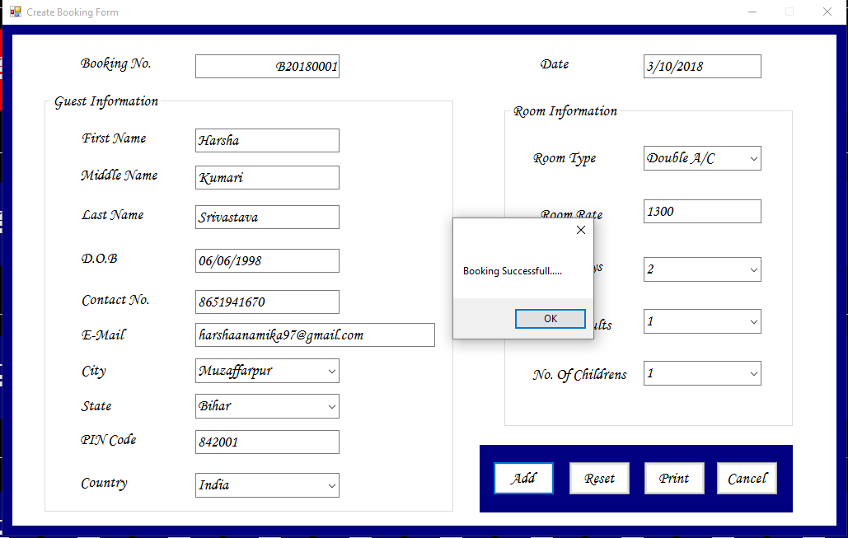

FrmCheckInForm:-

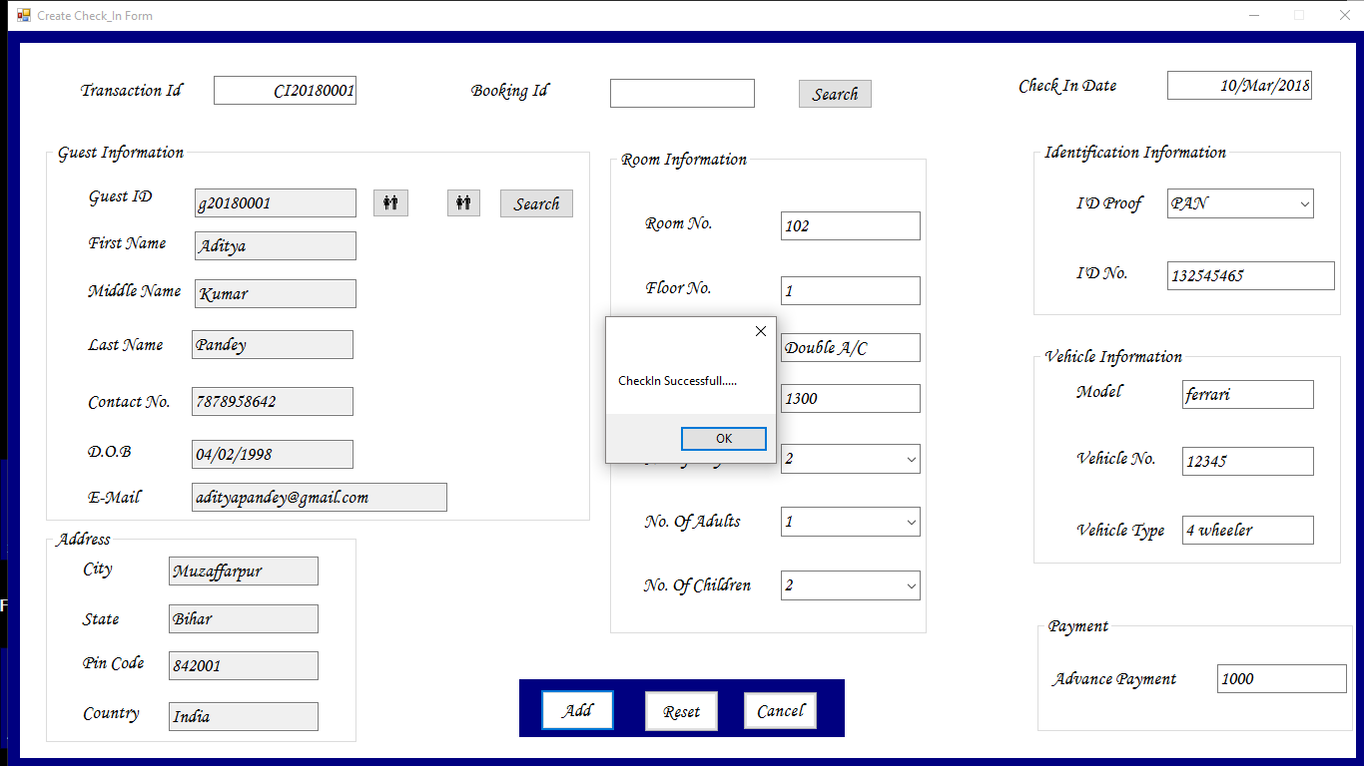

FrmCheckOutForm:-

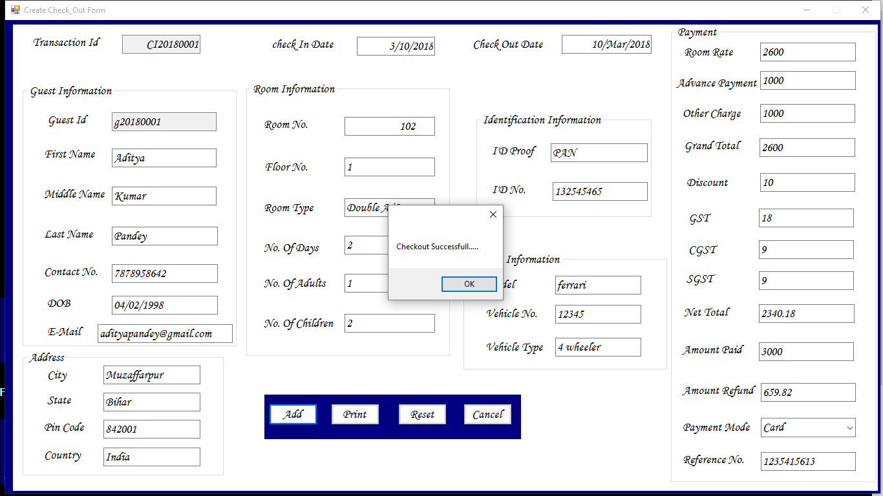

Testing

Software Testing is evaluation of the software against requirements gathered from users and system specifications. Testing is conducted at the phase level in software development life cycle or at module level in program code.Software testing determines the correctness, completeness and quality of software being developed. IEEE defines testing as 'the process of exercising or evaluating a system or system component by manual or automated means to verify that it satisfies specified requirements or to identify differences between expected and actual results.'

Software testing is closely related to the terms verification and validation. Verification refers to the process of ensuring that the software is developed according to its specifications. For verification, techniques like reviews, analysis, inspections and walkthroughs are commonly used. While validation refers to the process of checking that the developed software meets the requirements specified by the user. Verification and validation can be summarized thus as given here.

**Verification:** Is the software being developed in the right way?

**Validation:** Is the right software being developed?

Software testing is performed either manually or by using automated tools to make sure that the software is functioning in accordance with the user requirements. Various advantages associated with testing are listed below.

1. It removes errors, which prevent software from producing outputs according to user requirements.
2. It removes errors that lead to software failure.
3. It ensures that the software conforms to business as well as user's needs.
4. It ensures that the software is developed according to user requirements.
5. It improves the quality of the software by removing maximum possible errors from it.

# Future Scope And Limitations

Due to shortage of time and lack of knowledge I could not implement some feature which I have planned to incorporate in my application. One of them being a module for maintaining the Accounts. This configuration of my application is not having any module for this purpose but very soon I will implement a module for accounts in my application. Again because of lack of time and understanding I could not implement this feature. But in the next releases I will try to implement this feature to so that customers does not have to rely on offline information for anything.

Hotels were there in past, they are there now and they will be there in future too. Hence my work has lots of scope in future. Day by day new hotels are coming up and old hotels too are upgrading their old processes to newer information technology based processes. In this process, my application has all the possibility of growth. In a nutshell, I can say that my application will have a good demand in future.

# User Documentation

# Conclusion

It was a good learning experience to develop this project. Initially it was not an easy task, especially when I was going to develop my first project. But I was desperate to develop my project, so I started to develop this, with the help of my guide Manish Kumar Mishra, he helped me a lot. It was a hectic task but with his help I got it. I have given my best to it. During the development of this software I have understood the importance of software project management and software engineering to develop projects. This project has helped me to understand the software development life cycle as analysis, design, coding, testing and maintenance. Before doing this project I read all the life cycle of software development but that time I don’t understand the importance of these topics. But during project I know that analysis is the most important part of making software. As my view it is a useful application and can be popular if positively distributed. And from these experiences I will try to develop better projects in future.

# Bibliography

In the development of any software as a project books play a very important role. They guide us in various aspects like in concept on a topic, help in coding. And in this modern age internet also play a vital role in education. I got a lot of help in developing this project from various books and websites. The books and websites which I used to developing for my project are given below:-

***Books –***

1. Steven Holzer, **Visual Basic 2008 Black Book**
2. Bill Sheldon, Billy hollis, kent sharkey, Jonathan Marbutt, Rob Windsor, Gatson C. hillar, **Professional Visual Basic 2010 and .NET 4**
3. Steven Holzner, **.NET 3.5 framework vb, c#**
4. Roger S PressMan, **Software engineering**
5. Donald S, Le Vie, Jr, **Understanding Data flow diagrams.**

**Websites**

1. msdn.microsoft.com
2. social.microsoft.com/forums
3. www.w3schools.com
4. www.stackoverflow.com
5. www.codeproject.com
6. www.vbforums.com